

General Sir John Kotelawala Defense University

Faculty of Management, Social Science and Humanities

Department of Languages

BSc in Applied Data Science Communication

P.L.T.A Gunarathne-D/ADC/22/0001

D.M.G. Amasha-D/ADC/22/0024

K.E.U. Kankanamge-D/ADC/22/0032

M.R.M. Rihan-D/ADC/22/0038

Fundamentals of Data Mining /LB2114

Year 2: Semester 3

Assignment number 1

07.05.2023

Table of Contents

**Task 01**

**Maximize agricultural yield by recommending appropriate crops using classification algorithm and R.**

**1.1 Introduction1**

**1.2 Dataset4**

**1.3 Explanation and Preparation of Data set4**

**1.4 Data mining4**

1.4.1 The application of Data Mining techniques 5

• Classification

• K-Nearest Neighbor classifier (KNN)6

1.4.2 Test and Train Data Split 5

1.4.3 Visualization Tools 5

**1.5 Implementation in R 4**

1.5.1 Packages used. 5

1.5.2 Explanation of the experimental procedure and Visualization of the results5

**1.6 Data mining4**

1.6.1 The application of Data Mining techniques 5

• The corrplot of crop recommendation dataset

• The ggplot of crop recommendation dataset6

**1.7 Conclusion 4**

**1.8 Reference for task 014**

**Task 02**

**Implementing Clustering in Data Mining to Smart Cities KPIs**

**2.1 Introduction1**

**2.2 Dataset4**

**2.3 Explanation and Preparation 4**

2.3.1 Explanation 5

2.3.2 Preparation 5

**2.4 Data Mining4**

2.4.1 Clustering 5

2.4.2 K mean Clustering5

2.4.3 Elbow Method5

2.4.4 R provides visualization tools for clusters5

**2.5 Implementation R 1**

**2.6 Result analysis and Discussion 4**

**2.7 Conclusion 1**

**2.8 Reference for task 024**

**Task 03**

**Implementation of market basket analysis using association rules mining**

**3.1 Introduction1**

**3.2 Dataset4**

**3.3 Explanation of the Dataset 4**

**3.4 Preparation of datasets 4**

**3.5** **Implementation in R Software 1**

**3.6 Data Mining4**

**3.7 Results analysis and discussion 4**

**3.8 Conclusion 4**

**3.9 Reference for task 03**

**Task 04**

**Power bi dashboard for cost of living with smart cities KPIs**

**4.1 Introduction1**

**4.2 Exploration of dataset4**

**4.3 Dashboard Design and implementation 4**

Task 01

MAXIMIZE AGRICULTURAL YIELD BY RECOMMENDING APPROPRIATE CROPS USING CLASSIFICATION ALGORITHM AND R.

**1.1 INTRODUCTION**

Agriculture is the cultivation of crops and keeping animals for food, fiber, and other items. It has been an essential aspect of human culture for thousands of years and continues to be so now. Agriculture has played an essential role in human life since the dawn of civilization. People began to focus on maximizing the harvest from their harvests as the globe developed since it is important socially and economically.

Agriculture has several issues because of globalization, climate change, and a growing population, all of which must be handled to maintain sustainable development. To meet these issues, we must focus on new technologies along with agriculture. Precision farming and artificial intelligence are examples of modern technologies that can help with this. These technologies have the potential to boost crop yields, decrease waste, and improve sustainability.

Because of this task, we aim to create a classification algorithm in R that proposes better crops to maximize harvest by considering environmental aspects such as rainfall, humidity, and nutrition such as N, P, K, and so on.

**1.2 DATA SET**

The data set was taken from: <https://dataverse.harvard.edu/dataset.xhtml?persistentId=doi:10.7910/DVN/4GBWFV>

This dataset contains information that allows users to create a predictive model that recommends the best crops to grow in a certain farm based on a variety of characteristics. This dataset was created by combining rainfall, climate, and fertilizer data from India.

Farmers may be unsure about which crops to cultivate based on environmental facts to ensure a decent harvest. If they can discover it by finding patterns and insights in previous data, they will be able to reach a more accurate opinion about what they should cultivate to meet their goal. This data set can help us understand how rainfall, ph level, humidity, and nutrition like N, P, and K affect plant growth, and which crops are better to grow in different conditions like high rainfall, high N ratio, and so on.

**1.3 EXPLANATION AND PREPARATION OF DATA SET**

Crop recommendation data set has been used for the classification task. There are 8 columns and 2200 rows in the data set. In the data set the first 7 columns show the different parameters to recommend the crop and the 8th column shows which crop is recommended to grow according to values of parameters. The 8 main variables that are used for classification are mentioned below.

* N- Ratio of nitrogen content in soil
* P- Ratio of phosphorus content in soil
* K- Ratio of Potassium content in soil
* Temperature- Temperature in degree Celsius
* Humidity – Relative humidity in %
* ph- ph value of the soil
* Rainfall- rainfall in mm
* Label- the plant recommended for relevant condition.

In this data set, except the column” Label” all other variables can be named as independent variables (N, P, K, Temperature, Humidity, Rainfall, Ph). Only the variable “Label” is the dependent variable and that depends on independent variables.

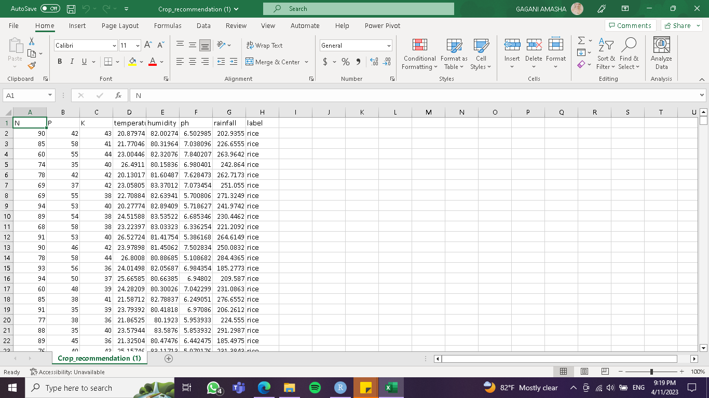

**1.4 DATA MINING**

Data mining is a technique that uses computational and statistical tools to extract patterns and insights from big data collections. It is used in a variety of fields to find hidden relationships and patterns that can be exploited for strategic planning and decision-making. We often use data mining techniques like clustering, classification, association rule mining, and regression analysis.

1.4.1 The application of Data Mining techniques

Classification

The goal is to apply classification to the crop recommendation data set. Classification is the categorization of distinct elements into different classes. There are two types of classification issues: binary (only two classes are feasible) and multi-class. (With more than two possible classes).

K-Nearest Neighbor classifier (KNN)

K nearest neighbors is a classification and regression analysis machine learning technique. The measure used to determine the closest neighbors may differ, but prominent metrics include Euclidean distance, Manhattan distance, and Minkowski distance.

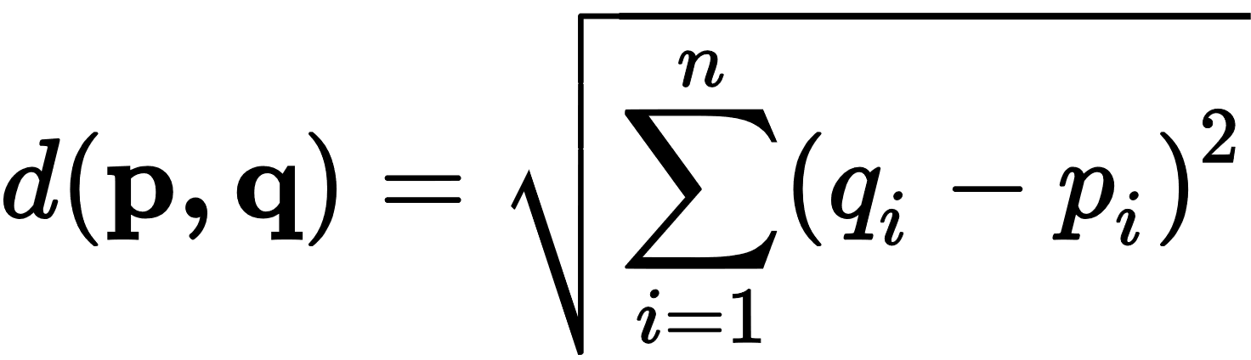

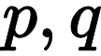 = two points in Euclidean n-space

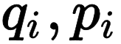 = Euclidean vectors, starting from the origin of the space (initial point)

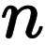 = n-space

1.4.2 Test and Train Data split

The process of developing a model in machine learning classification tasks typically entails splitting the available data into two distinct sets: the training set and the test set. We train the model using the observations from the training dataset, and then use it to make predictions from the testing dataset.

The split of the test and train data produced the following results, according to the model we designed.

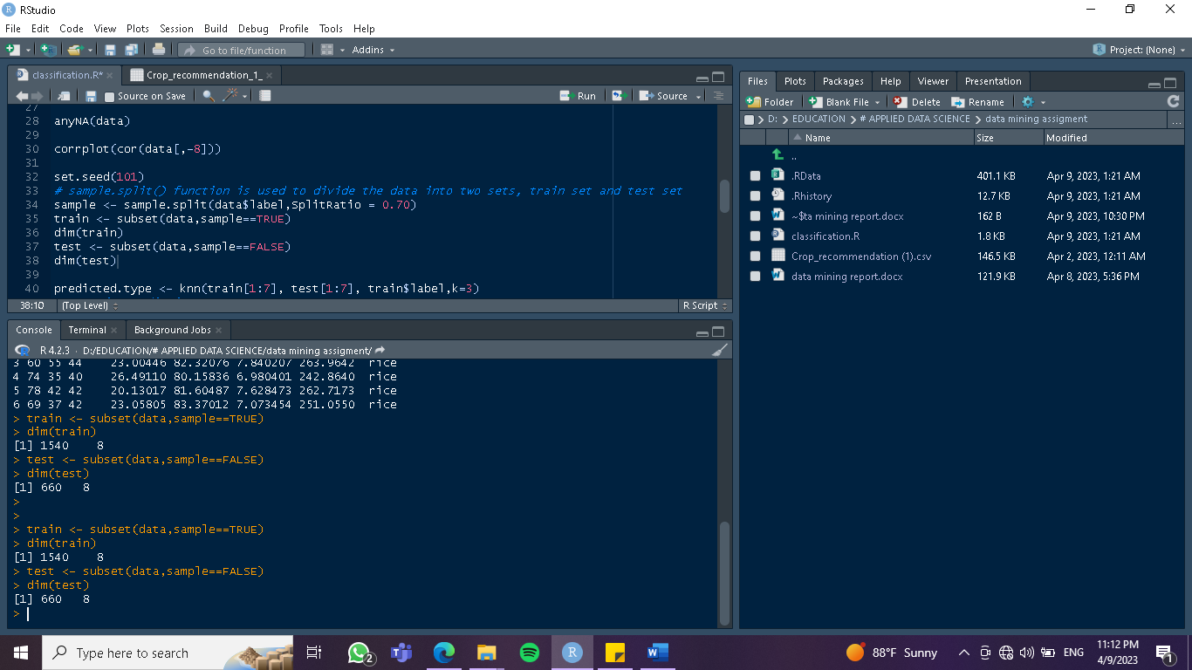

1.4.3 Visualization Tools

An R package called corrplot offers a tool for visualizing correlation matrices. Scatterplot matrices, color-coded correlation matrices are just a few of the correlation plot types offered by the corrplot program. These plots can be used to find patterns in the correlation matrix and to investigate the strength and direction of correlations between a lot of different variables.

**1.5 IMPLEMENTATION IN R**

1.5.1 Packages used.

**• caTools** - provide a variety of functions for a variety of purposes, such as data splitting, random number generation, moving averages, and others.[ *sample.split(),runmean( ),runmad( )* ]

**• dplyr** - provides a set of functions designed to operate smoothly with data frames, allowing users to execute operations such as filtering, summarizing, grouping etc... [*filter( ), select( ), mutate( )]*

• **ggplot2** - The R package ggplot2 is based on the layered grammar of graphics that allows users to quickly mix different graphical elements to create personalized plots. [*ggplot( ),aes( )* ]

• **class** - contains utilities for performing classification and regression analysis with various machine learning algorithms. [*knn(), qda(* ) ]

• **caret** – provides a uniform interface for numerous machine learning techniques and contains data preprocessing, feature selection, model tuning, and model assessment capabilities. [*predict (), train()*]

• **corrplot** – For changing the appearance of correlation graphs, such as color schemes, text size, and text orientation. [*corrplot(),order( )* ]

1.5.2 Explanation of the experimental procedure and Visualization of the results

Step 01

Use the ‘library(readr)’ function to import the data to R.

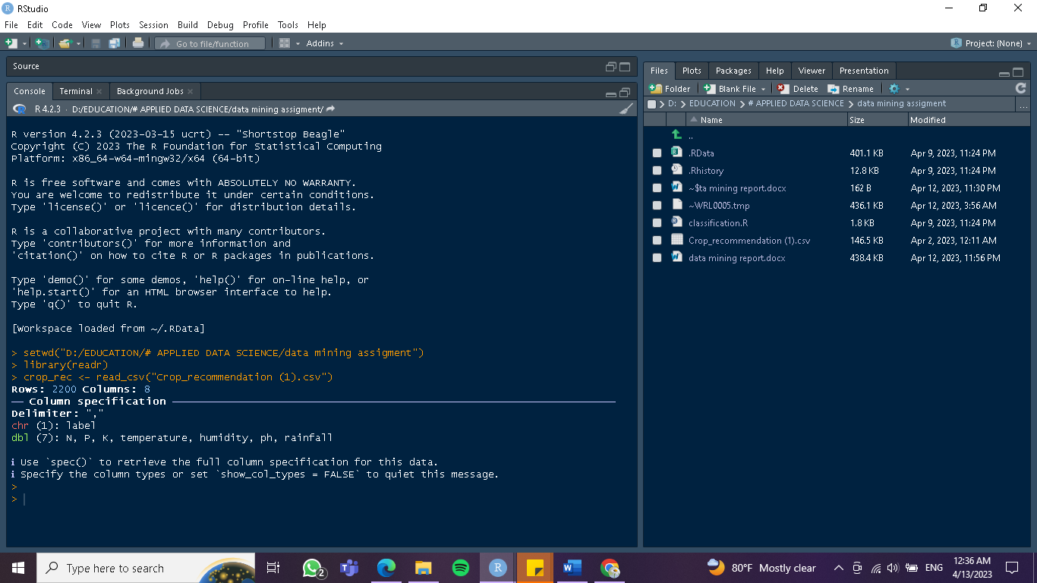

Step 02

Use ‘names( )’ function to understand the main categories of this data set

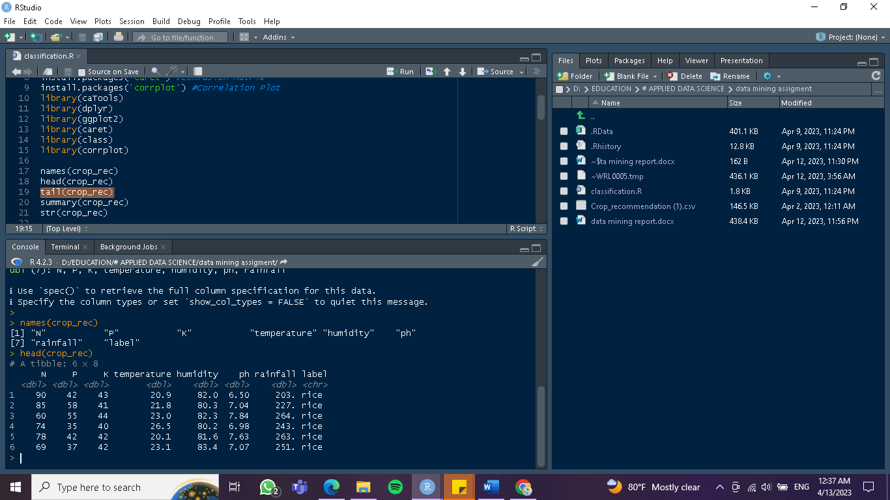

Step 03

Use the ‘summary( )’ function to take the summary of this data set

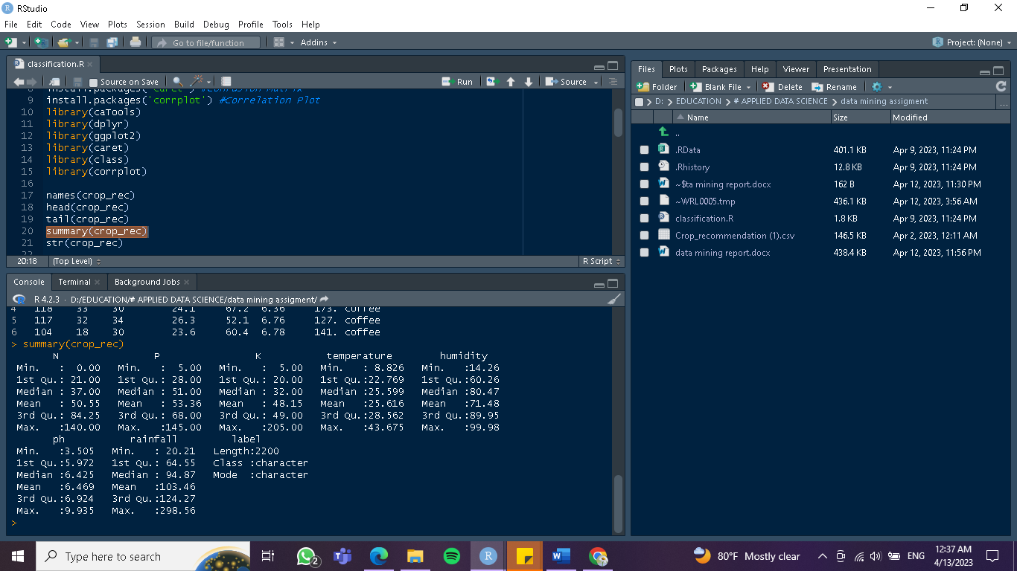

Step 04

Use the ‘head( )’ and tail( ) to get the first few rows and last few rows of the dataset to get an overall idea about the data set

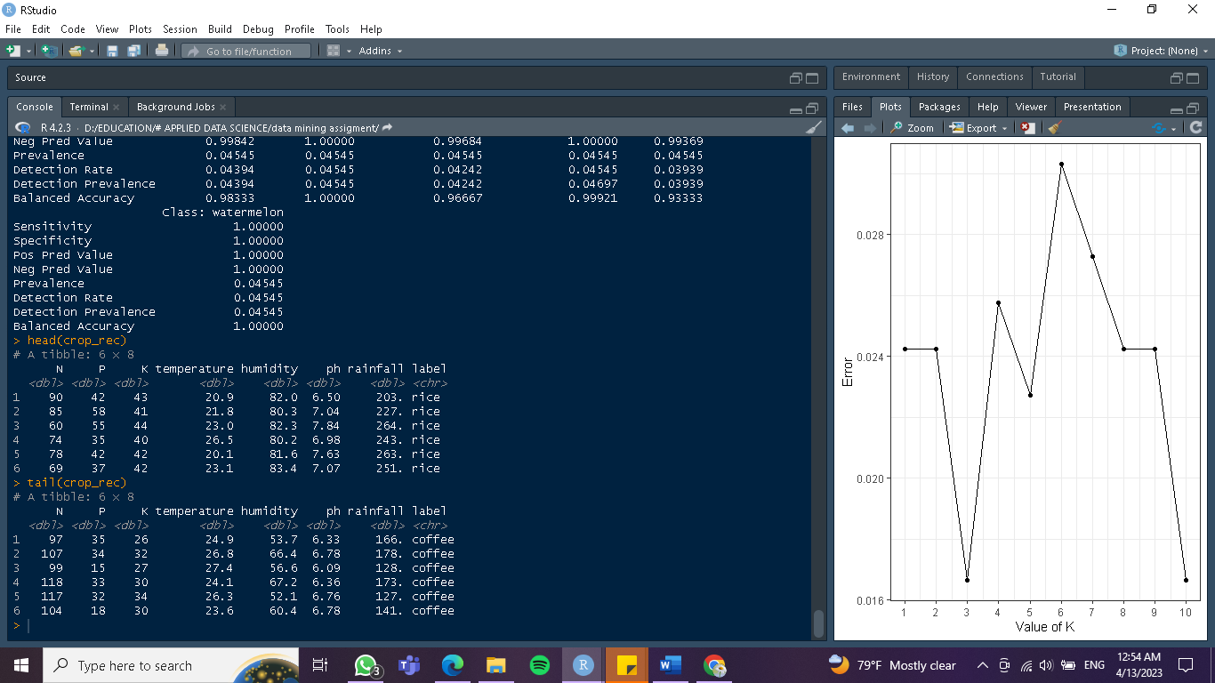

Step 05

Use the str ( ) function to get the names of the columns, class of each column, followed by some of the initial observations of each of the columns.

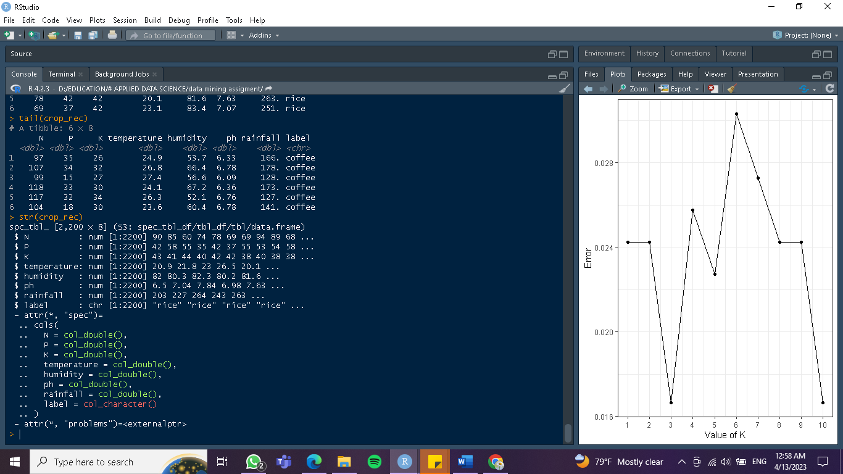

Step 06

Then we used the dim function to get the dimensions of the specified matrix on the data

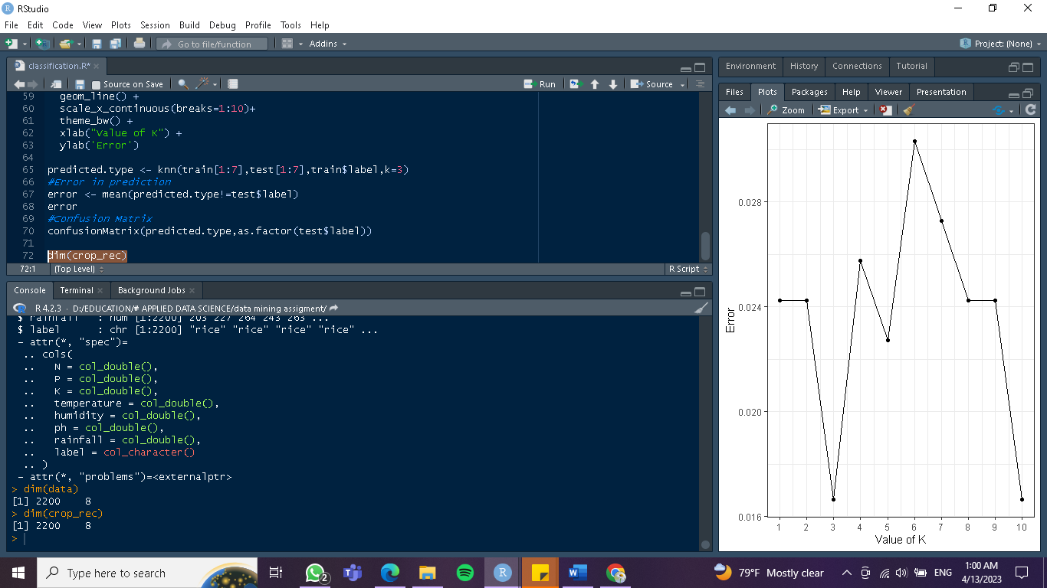

Step 07

Use scale() function to standalize the features of the data set and assign it to new variables

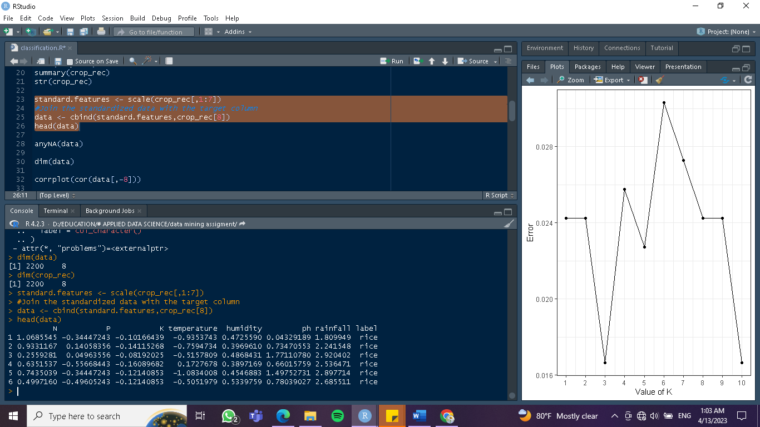

Step 08

Check if there are any missing values to impute.

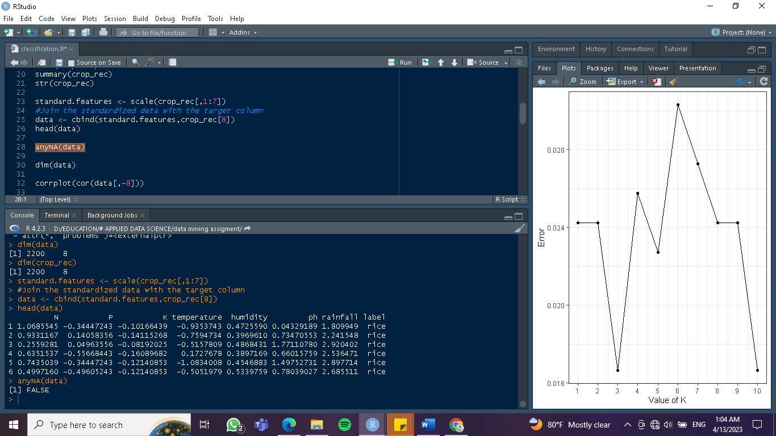

Step 09

In here we used corrplot to understand the distribution of this dataset by this plot. And it makes it easier to understand the data set more easily.

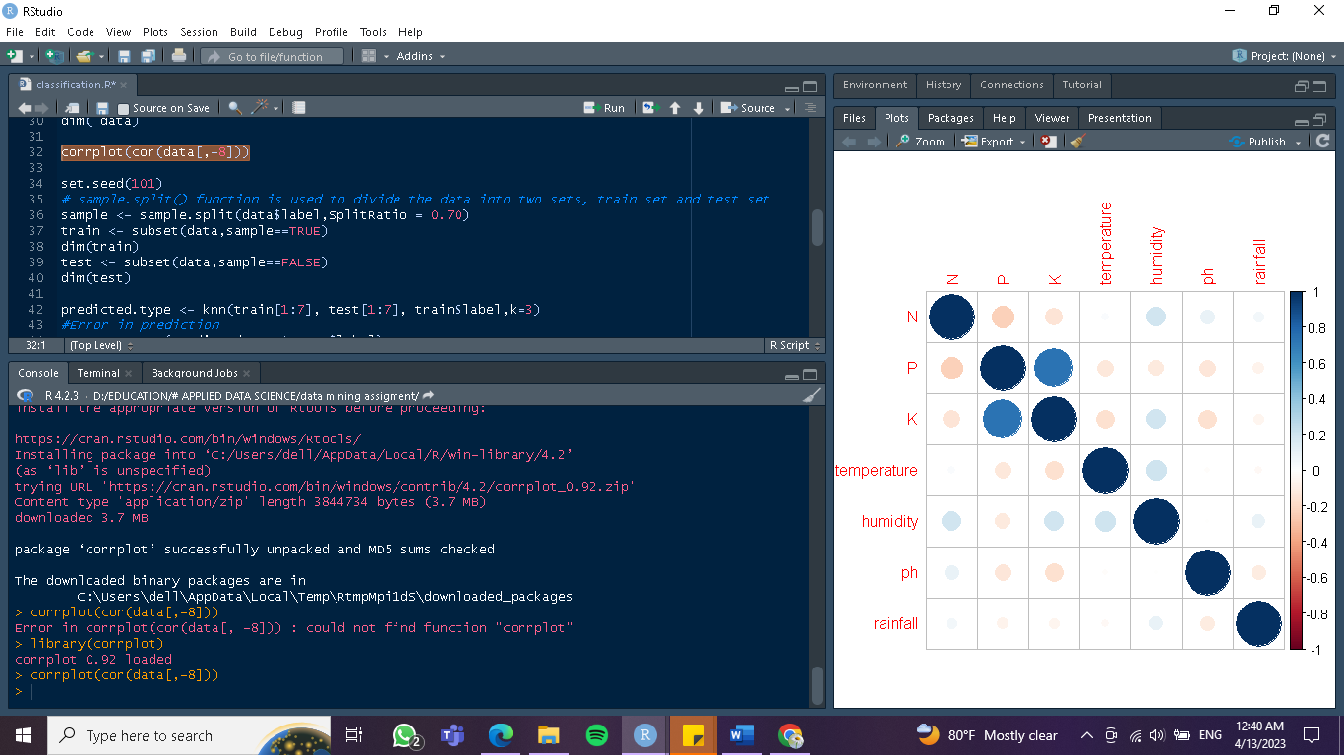

Step 10

split the data as train and test data using sample.split function with a splitRatio=0.70

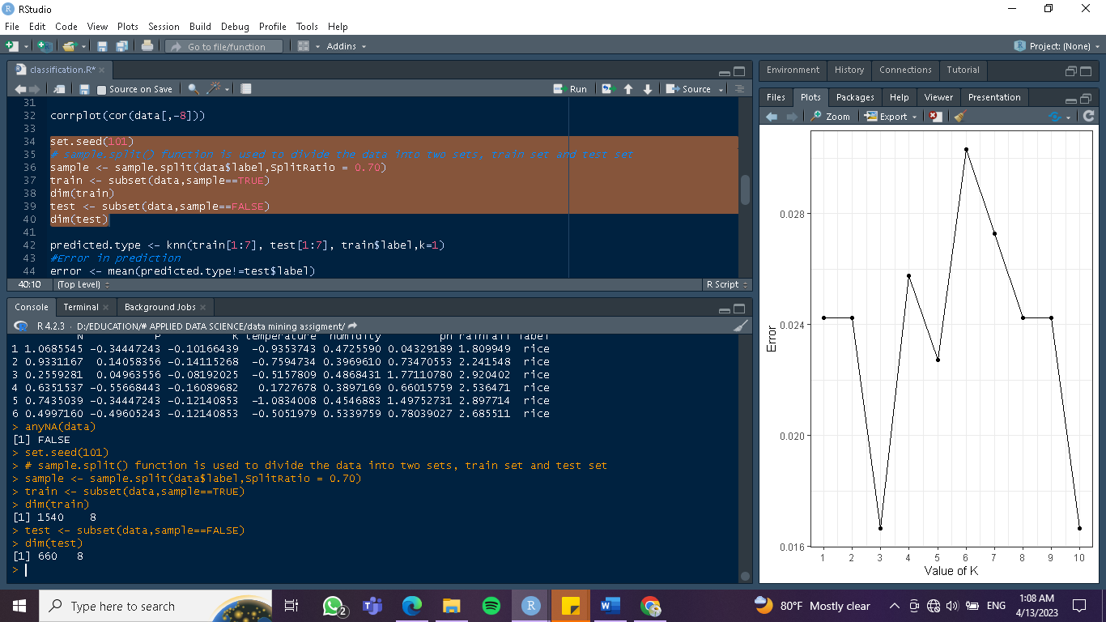

Step 11

Use knn( ) function to predict our target variable type of the test dataset with k=1

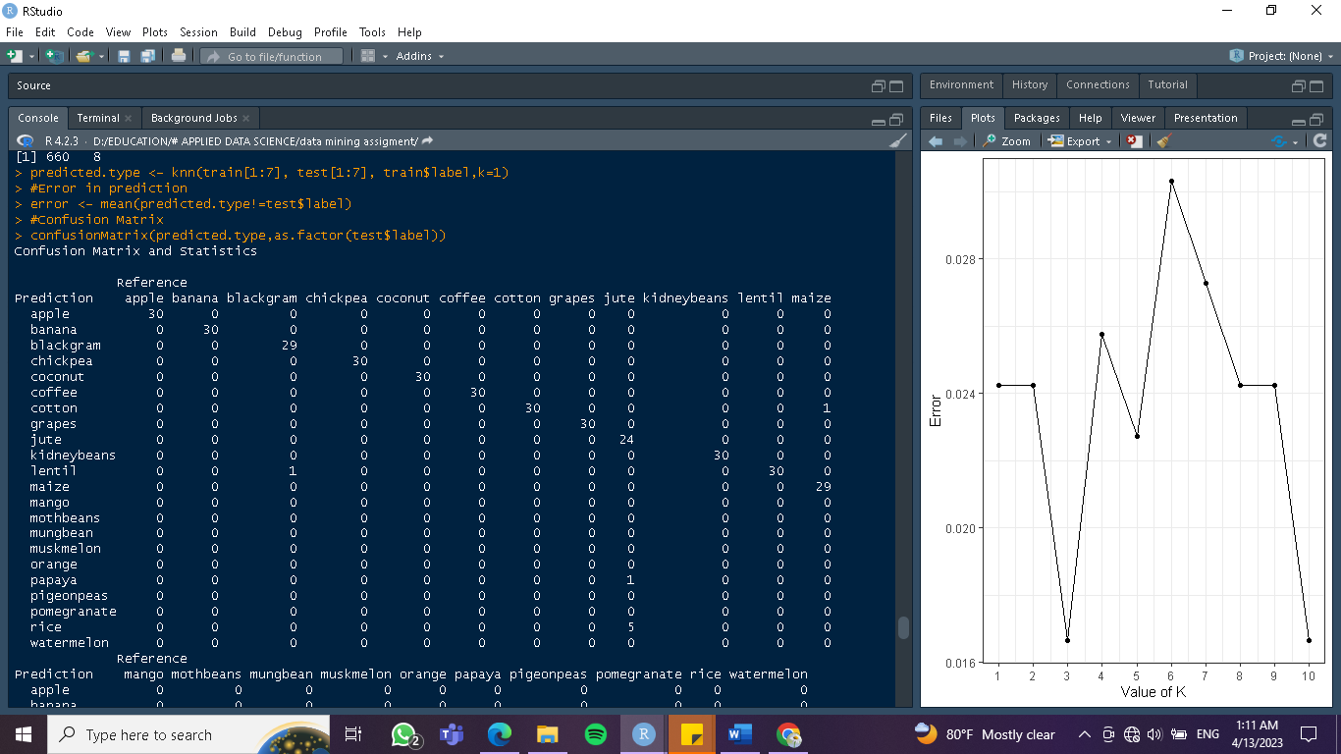

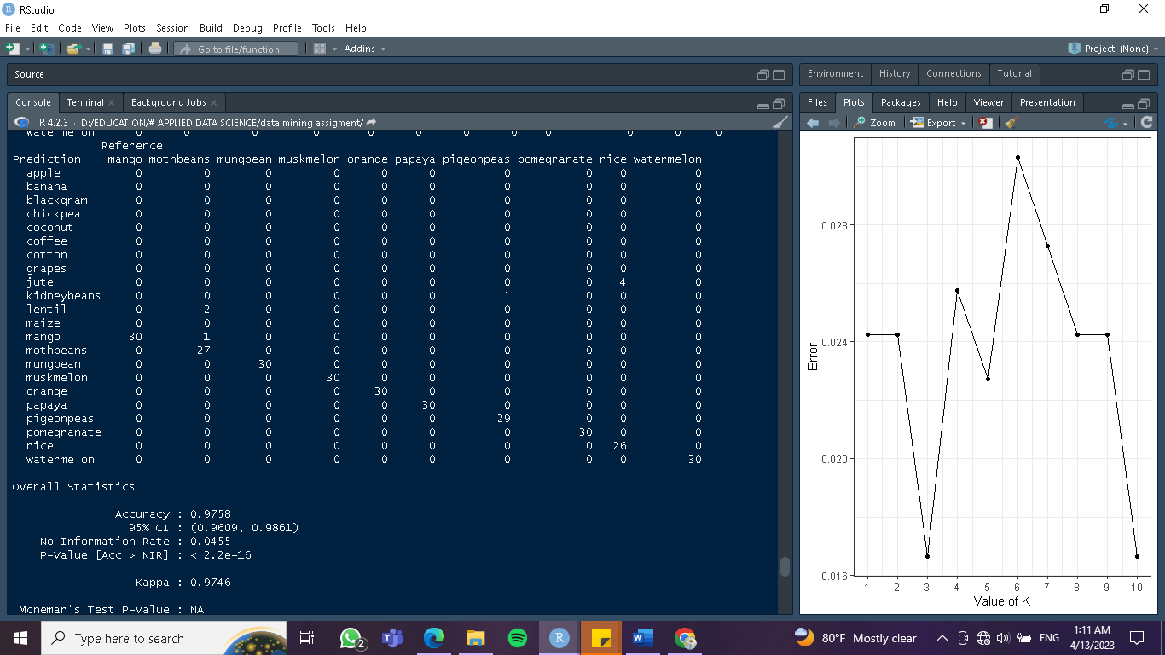

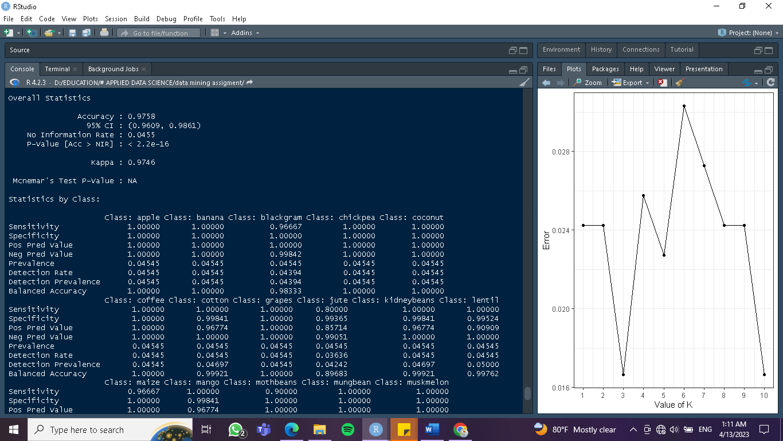

The above results reveal that our model achieved an accuracy of 97.58%.

Step 12

try different values of k and assess our model. [ calculate the Euclidean distances in the dataset]. obtain the result of

according to results, the lowest error, or the k value is at 3

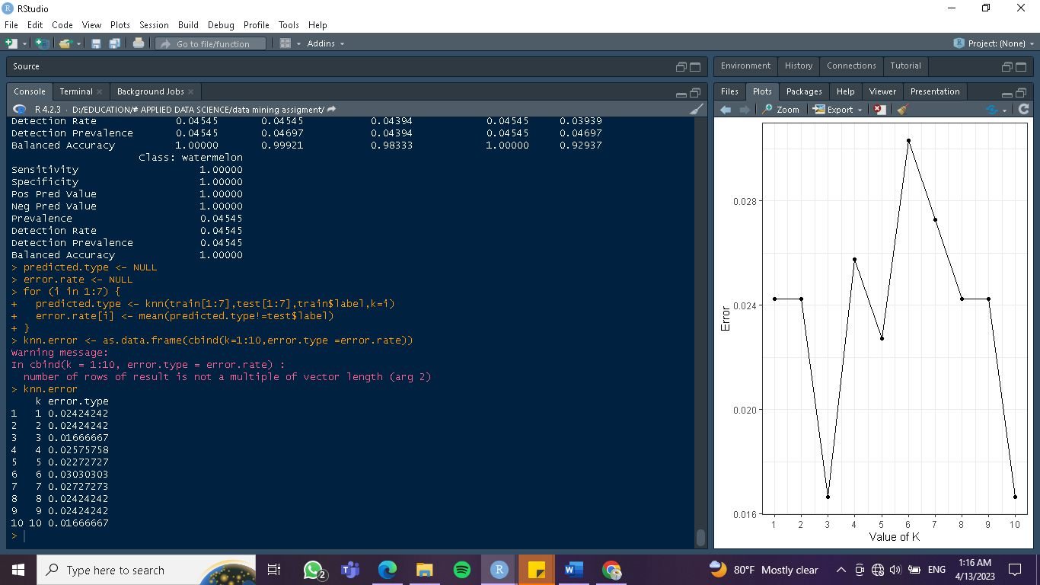

Step 13

plot error. Type vs k using ggplot.

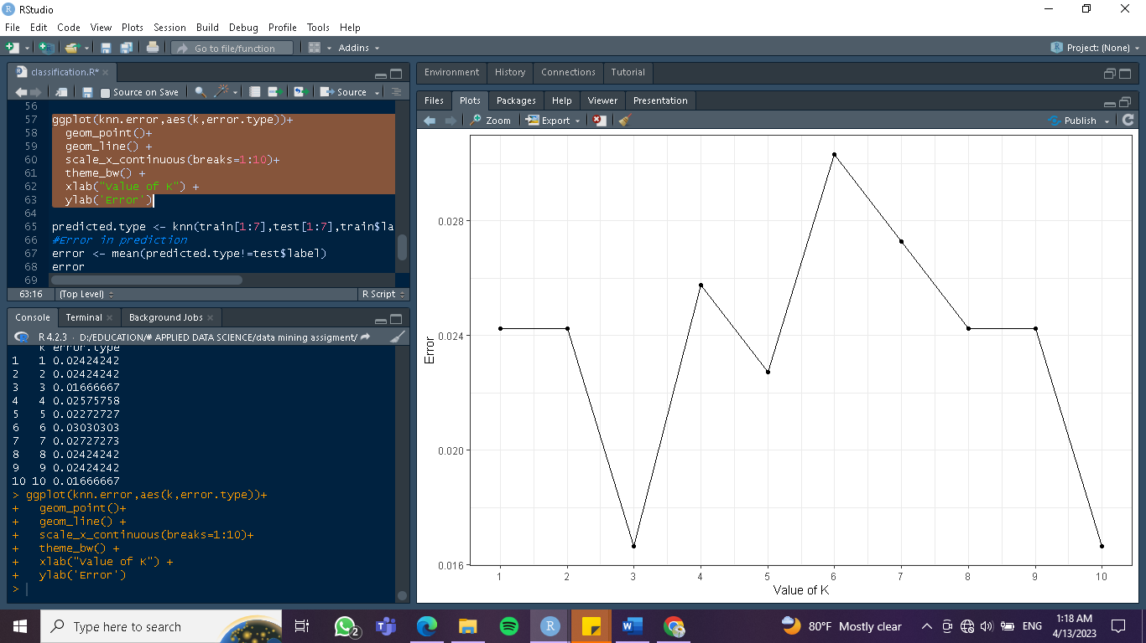

The above plot reveals that error is lowest when k=3 and then jumps back high revealing that k=3 is the optimum value. Now let’s build our model using k=3 and assess it.

Step 14

Do the same as step 11 and Get results.

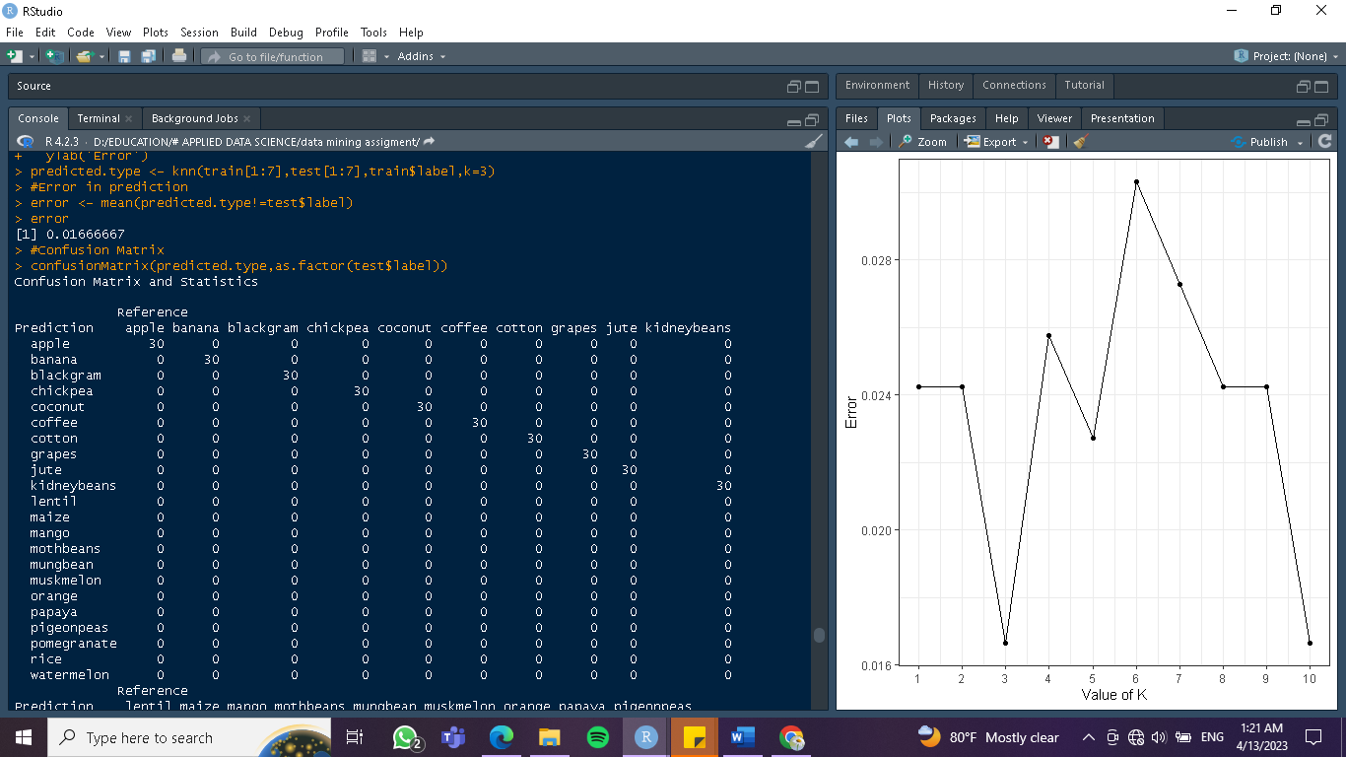

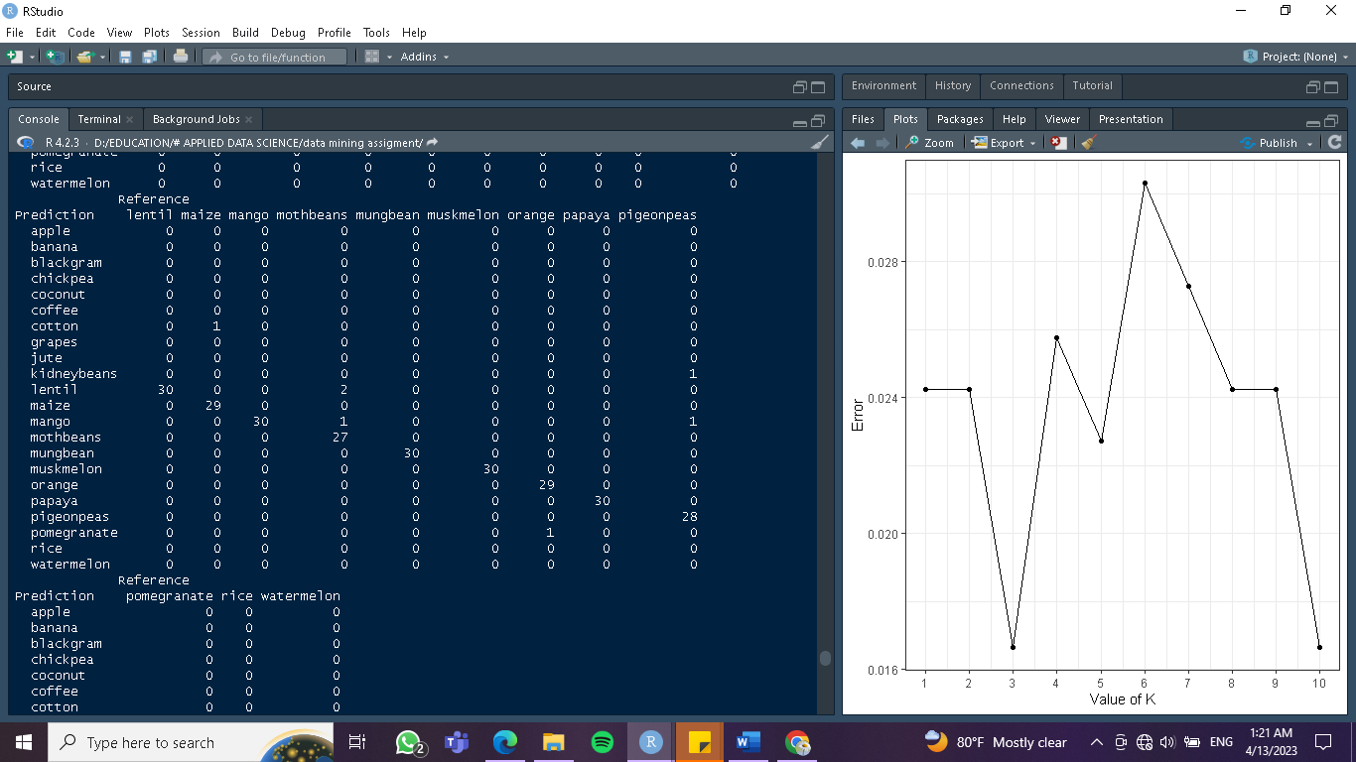

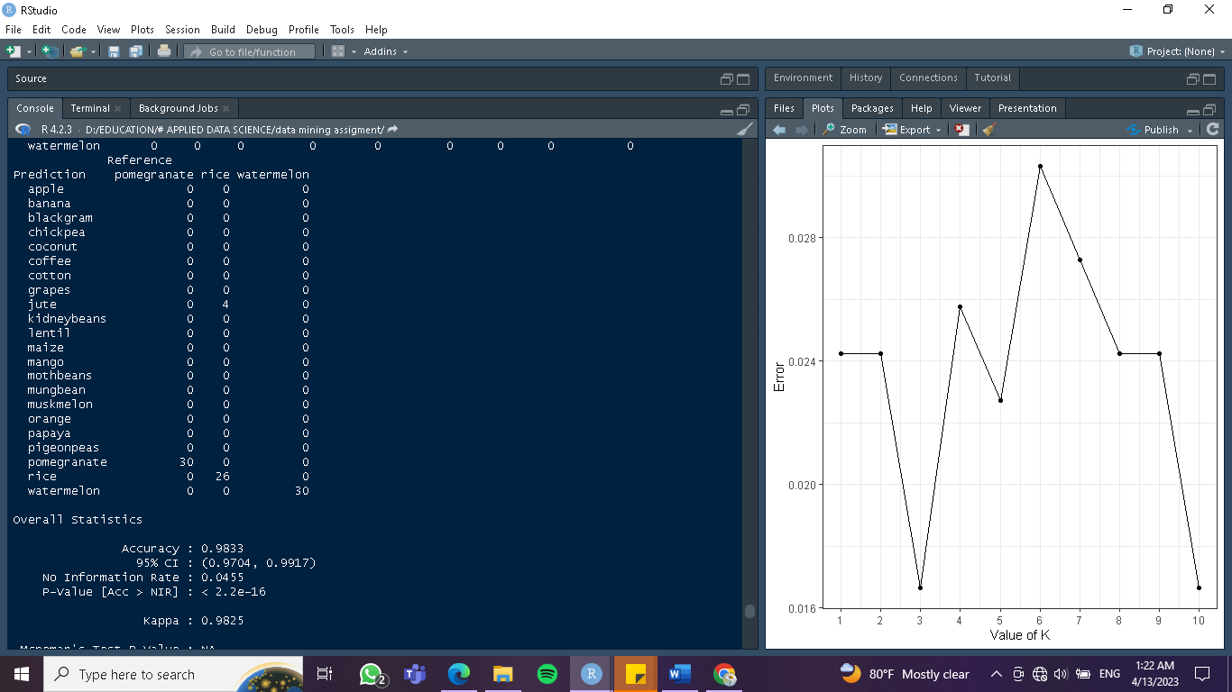

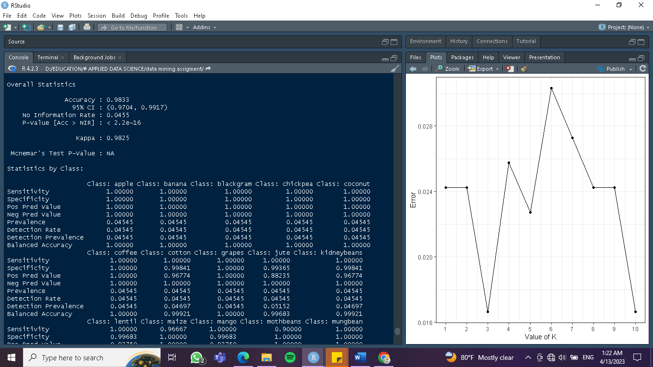

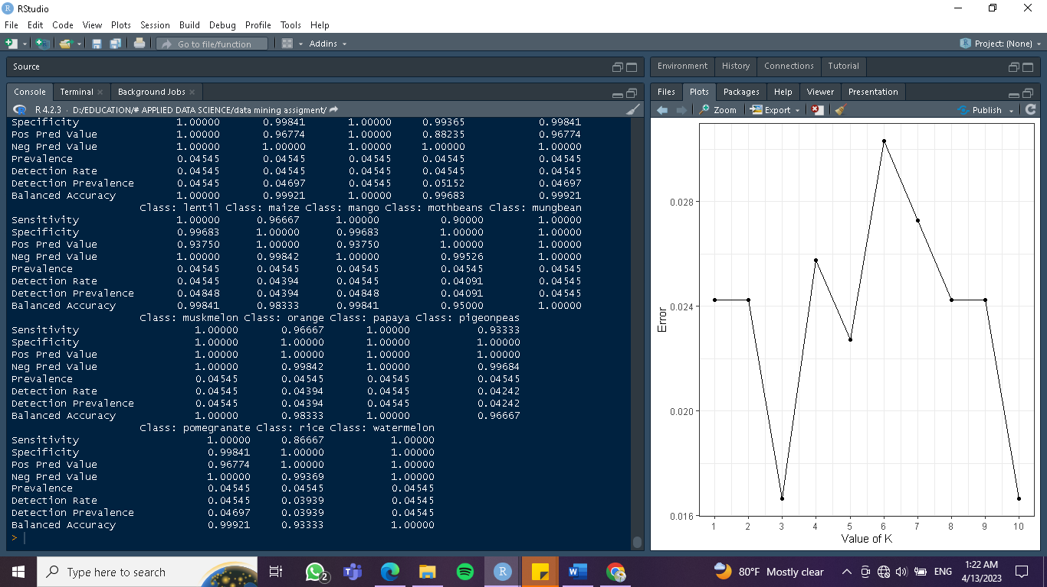

Above Model gave us an accuracy of 98.33 %

**1.6 RESULTS ANALYSIS AND DISCUSSION**

When analyzing the above results, we have confirmed that our classification of data mining results was accurate. So, this result confirms that this model can be used to recommend crops for a maximum harvest. As well as this helps to identify the how the parameters affect to different crops growth.

With the aim of applying classification for this data set, we were able to understand the patterns and the co relations of the different parameters. That fact helped to understand how the parameters affect the growth of crops and which crop is giving the best harvest depending on selected parameters. According to this dataset we have calculated the accuracy of this data set is around 98%.

1.6.1 Presentation of the results

The corrplot of crop recommendation dataset

Figure 1.6.1.1 explains the relation between different features in crop recommendation dataset. It has a value between -1 and 1 where,

• -1 indicates a perfectly negative linear correlation between two variables

• 0 indicates no linear correlation between two variables

• 1 indicates a perfectly positive linear correlation between two variables.

Color intensity and the size of the circle are proportional to the correlation coefficients.

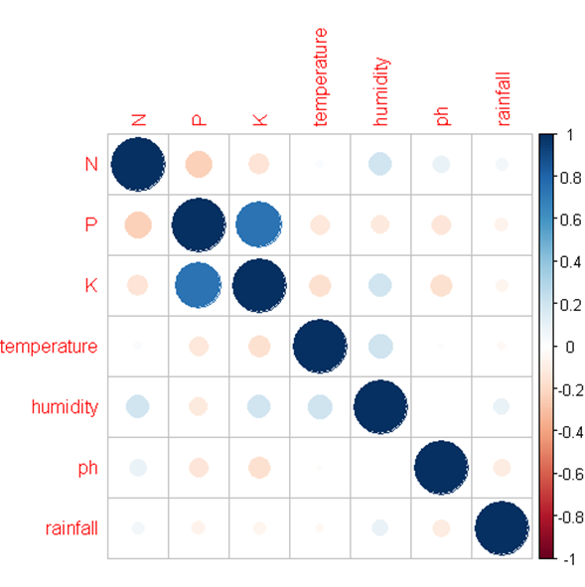

Figure 1.6.1.1

The ggplot of crop recommendation dataset

According to figure 1.6.1.2 the error is lowest when k = 3. The error is lowest when k = 3and it is highest when k = 8. It reveals that k = 3 is the optimum value.



Figure 1.6.1.2

**1.7 CONCLUSION**

Since the beginning of civilization, agriculture has been a vital part of human life. As the world progressed, people started concentrating on maximizing their harvests since it is significant from a social and economic standpoint. Modern farms and agricultural enterprises operate much differently than they did decades ago, largely because of technological developments in the form of sensors, machinery, and technology.

Data mining is another advanced technology sector that can be applied to agriculture. Using data and analytics, it identifies the best methods for maximizing yield and productivity in agriculture. This task is one of the demonstrations that show how we may apply classification techniques in machine learning for crop recommendation with multiple parameters to maximize yield and production. Because of applying the KNN model to this crop recommendation data set, we obtained an accuracy of 98.33%. As a result, we may expect that this model will be preferred for practical operations in agriculture.

**1.8 REFERENCE FOR TASK 01**

<https://dataverse.harvard.edu/dataset.xhtml?persistentId=doi:10.7910/DVN/4GBWFV>

https://www.youtube.com/watch?v=e99LZoii3ng&t=336s

Task 02

IMPLEMENTING CLUSTERING IN DATA MINING TO COST OF LIVING

**2.1 INTRODUCTION**

KPIs are measurable values used to assess the performance and success of an organization, project, or operations. They can help cities monitor their performance and identify areas for improvement.

The cost of living is the amount of money required to maintain a certain level of living in a specific location or region. It includes the expense of essential necessities such as housing, food, utilities, healthcare, transportation, and entertainment. It can vary greatly depending on factors such as local wages, taxes, and availability and pricing of goods and services. The cost-of-living index compares the relative cost of living in various places throughout the world. It covers a variety of criteria such as the cost of groceries, rent, transportation, and utilities. It is often determined by comparing the cost of one city's basket of goods and services to the same basket of goods and services in another city. Cities with a high cost of living tend to have higher pricing for products and services, making it more difficult for citizens to maintain a reasonable standard of life.

**2.2 DATA SET**

The dataset available at https://www.numbeo.com/quality-of-life/ contains information related to the cost of living for smart cities. It gives data on the cost-of-living index for cities all over the world. The cost-of-living index compares the prices of products and services such as groceries, restaurants, transportation, utilities, and rent to determine the relative cost of living in different cities. A city with a higher cost of living index score is more expensive to live in than one with a lower cost of living index score.

The dataset contains 511 rows, each with 7 columns. Attributes of the dataset are,

* City
* Cost of living Index
* Rent Index
* Cost of Living Plus Rent Index
* Groceries Index
* Restaurant Price Index
* Local Purchasing Power Index

The cost of living in various locations can be evaluated using rental expenses, grocery costs, and restaurant pricing. The local buying power index can provide context by highlighting how inexpensive the cost of living is relative to the income of the local population. These characteristics can be used to evaluate the cost of living in various locations.

**2.3 EXPLANATION AND PREPARATION OF DATASET**

2.3.1 Explanation of Data set

This dataset is used to examine city performance on various KPIs and indexes, compare city performance, and discover areas for improvement. The cost-of-living index is the dependent variable, while the rent index, cost-of-living plus rent index, grocery index, restaurant pricing index, and local purchasing power index are the independent variables. The key variable of importance in this dataset is the cost-of-living index, which indicates the overall cost of living in a certain city. The remaining variables are potential cost-of-living index drivers since they indicate specific elements that can influence the cost of living in a certain location. For example, the rent index and the cost of living plus rent index are both independent factors that might influence the cost-of-living index. Higher food and restaurant expenses can also contribute to a higher overall cost of living.

|  |  |
| --- | --- |
| **Variable** | **Explanation** |
| City | The name of the city |
| Cost of Living Index | The numerical value represents the city's cost of living |
| Rent Index | The numerical value represents the cost of renting a city apartment |
| Cost of Living Plus Rent Index | The numerical measure represents the whole cost of living in the city, including rent. |
| Groceries Index | The numerical figure represents the city's grocery expenditures. |
| Restaurant Price Index | The monetary number represents the expense of dining out in the city |
| Local Purchasing Power Index | The numerical value represents the local population's purchasing power |

2.3.2 Preparation of Data set

It appears that the data has already been pre-processed and cleaned, as there are no obvious missing values or outliers. However, without more information on the specific goals of the analysis, it is difficult to determine whether normalization is necessary.

Normalization is a technique used in data preprocessing to scale numerical data to a common range. It is often used in machine learning and data analysis to improve the performance and accuracy of models. Whether or not normalization is necessary for this dataset depends on the specific analysis being conducted and the algorithms being used.

* In summary, the file at the provided link contains data related to cost of living and may or may not require normalization depending on the specific analysis being conducted.

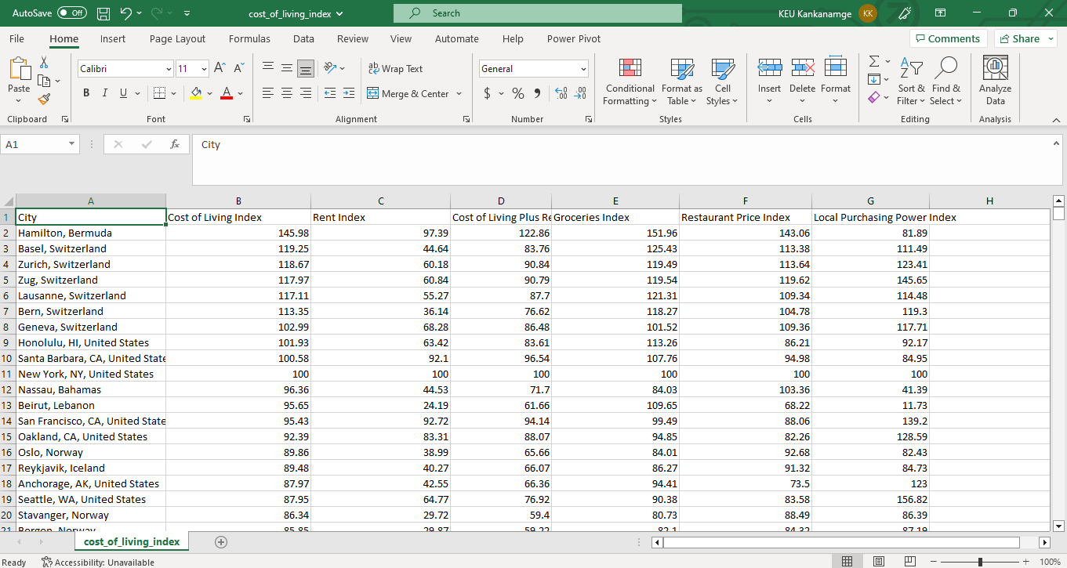

**2.4 DATA MINING**

Data mining is the process of analyzing large amounts of data to discover trends and patterns. Data mining can be used by businesses for a variety of purposes, including learning about what customers want to buy and detecting fraud and spam. This method of data mining has recently come under fire because consumers are frequently unaware that their personal information is being collected. For each type of data mining application, a collection of algorithms is used to extract the key correlations in the data. These approaches differ depending on the problem at hand.

In this project, we will use "cluster" packages that employ the K-means clustering Algorithm.

K-means (MacQueen, 1967) is one of the most basic unattended learning algorithms for solving the well-known cluster problem.

Then we must select the columns that will be used for clustering. We eliminated the columns "city" in this stage, which has no effect on the K mean clustering approach. The pair function was then used to construct a matrix of scatter plots, which aids in understanding the relationship between diverse variables.

2.4.1 Clustering

Clustering is the most often utilized approach in data mining. Cluster analysis is frequently used in many fields. Clustering has traditionally been termed unsupervised learning since it lacks a class label or quantitative response variable, which are present in supervised learning such as classification and regression. Clustering is the partitioning of data into groups of related things. When data is represented by fewer clusters, some fine details are lost, but the data is simplified. Data is formed by groupings. Data modeling places clustering in a historical context anchored in mathematics, statistics, and numerical analysis.

2.4.2 K-means clustering

The purpose of using k means clustering on our data is to extract some helpful information. K-means clustering is a simple and widely used unsupervised machine-learning technique.

Unsupervised algorithms typically make conclusions from datasets using only input vectors and without reference to prior knowledge.

The K-means algorithm operates as follows:

The K-means data mining technique begins with a set of randomly chosen centroids that serve as the starting points for each cluster and then performs iterative (repetitive) computations to maximize the centroids' placements.

* Step 1: Choose k has randomly chosen locations to serve as cluster centers.
* Step 2: Determine the Euclidean distance between each data point and the center of each cluster.
* Step 3: Assign the datapoint with the least Euclidean distance to the cluster.
* Step 4: Recalculate the cluster centroids using the data points from Step 3.
* Step 5: Repeat steps 2-4 until the centroids no longer update or the maximum number of iterations is reached.

2.4.3 Elbow Method

The elbow technique employs the k-means clustering algorithm for a range of k values.

1. It determines the best city for each k value.
2. By default, it computes the distortion city, which is the total of the squared distances between each datapoint and the center to which it has been assigned.
3. We get an elbow-shaped plot when we plot the value of k against this score, hence the name.
4. The elbow point is where the distortion is the least and where the ideal value of k is obtained.

2.4.4 R provides visualization tools for clustering.

We can create visually pleasing data visualizations with R by adding a few lines of code. To accomplish this, we make use of many of R's features. Data visualization is an effective method for viewing and understanding data.

* Cluster plot - Cluster plots are small clusters observed in scatter plots. The most common unsupervised machine learning strategy is k-means clustering, which divides a given data set into a collection of k groups, where k is the number of groups that the analyst has pre-specified. Cluster analysis and fact analysis are ways for breaking down items into fewer components.
* Scatterplot matrix - A scatterplot matrix can demonstrate the correlations between many variables. After charting two-way combinations of the variables to highlight which linkages are likely to be essential, the matrix can indicate relationships between variables. The matrix may help detect outliers in different scatter plots.
* Distance Matrix - The distances between rows of a matrix or data frame are displayed in this plot. In this approach, the factoextra R package is employed, which facilitates the extraction and visualization of exploratory multivariable data analysis output.
* Dot plot - A dot plot, often known as a dot chart, is similar to a scatter plot. The primary difference is that the dot plot in R displays the index (each category) on the vertical axis, allowing the user to evaluate the value of each observation.

**2.5 IMPLEMENTATION IN R**

Clustering in R refers to the grouping of similar data into groups or clusters to discern one group from the others. R can also be used to represent this graphically. We used a few R packages for clustering.

* Cluster package: provides a variety of data clustering tools such as k-means, hierarchical clustering, and density-based clustering.
* ggplot package: a popular R program for making data visualizations. It offers a variety of choices for producing bespoke plots, such as scatterplots, line plots, bar plots, and more.
* Factoextra package: This R package makes it straightforward to extract and visualize the findings of exploratory multivariate data analysis.
* We collect the results of the key columns in the dataset using this code, so we can get an overview of the data we're going to use.

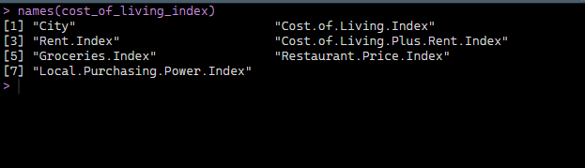

* This 'head' function was used to collect the first few rows in this dataset so we could figure out what kind of data is in it.

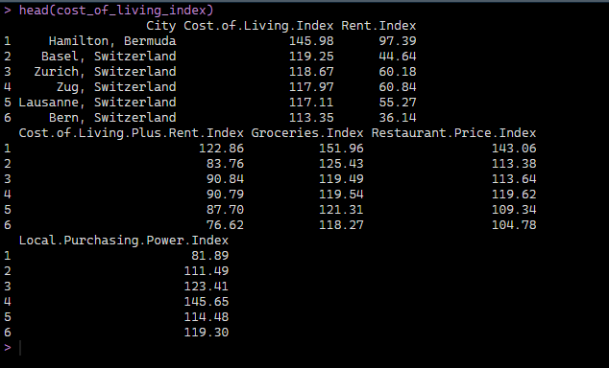

* This code is the same as the 'head' function but has the reverse reaction, therefore it offers us the last few rows in this dataset and helps us comprehend the distribution of this dataset when compared to the head function.

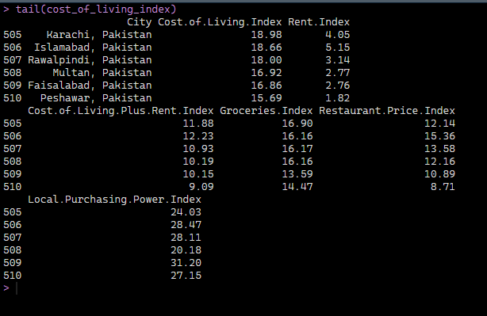

* This'summary' code is used to obtain a summary of this dataset so that we can grasp the length of each column, class, and character of each column.

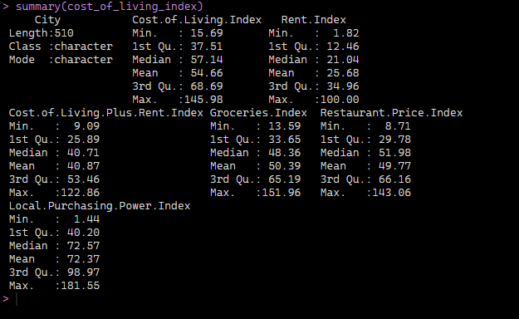

* We used 'str' code to obtain the result, which compactly displays the internal structure.

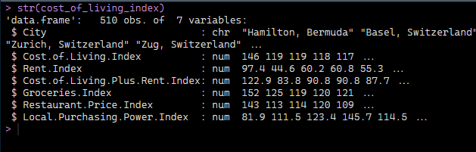

* Then we used the ‘nrow’, ‘ncol’, and ‘dim’ functions to get the result of a few rows and columns.

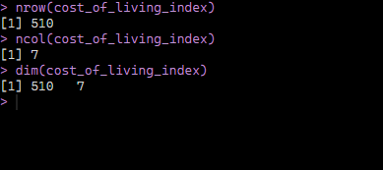

So, these are some R software programs that we utilized to study this dataset and gain a general understanding of it.

Following that, the pair function was used to build a scatter plot matrix, which aids in understanding the relationship between different variables.

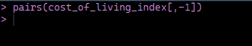

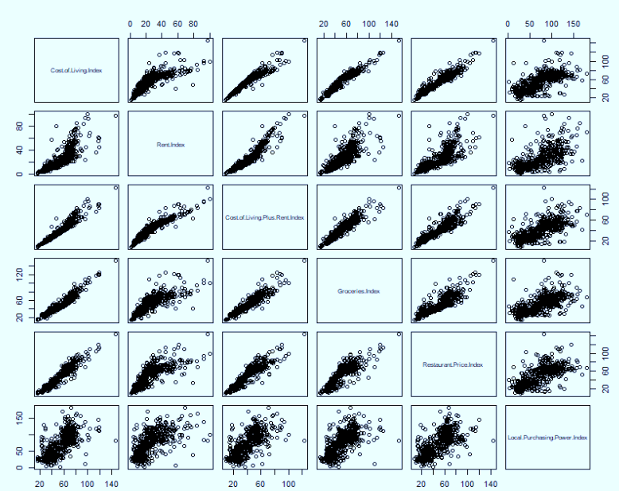

* Then we normalized the dataset using ‘normalise’ function.

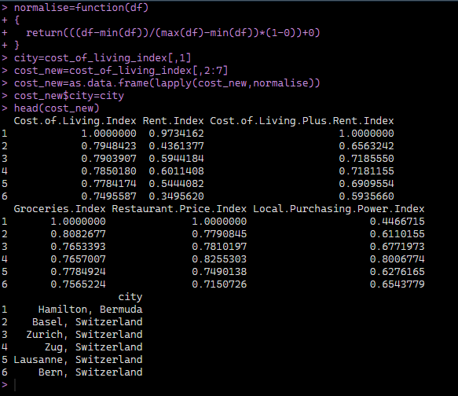

In clustering, the Euclidean distance is the most used distance measure. A scatterplot matrix can highlight the correlations between a variety of factors. After charting two-way combinations of the cities to highlight which associations are likely to be important, the matrix can reveal linkages between variables.

The following code was used to visualize the distance matrix.

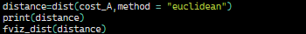

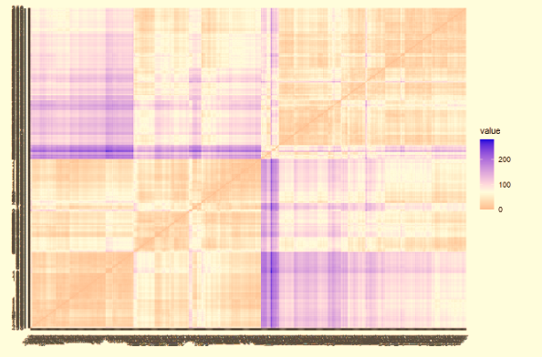

* We made a graph to determine the number of predicted clusters, sometimes known as the k values. We used the 'fviz_nbclust' code to build this graph.

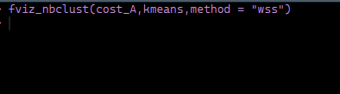

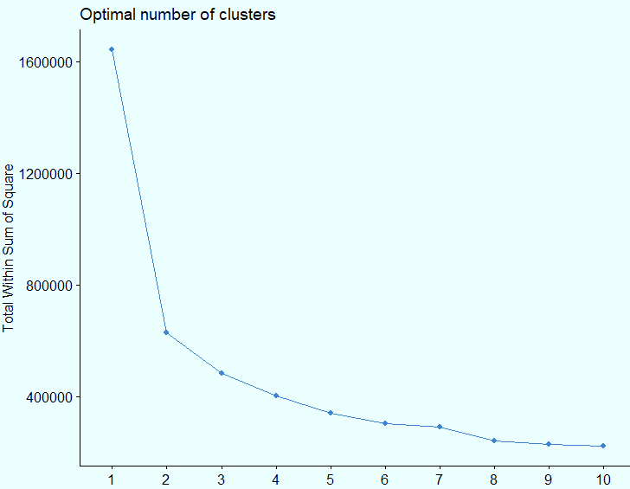

* Following R codes were used to generate the relationship between the rent index and the restaurant index and to remove the

overlapping of the plot.

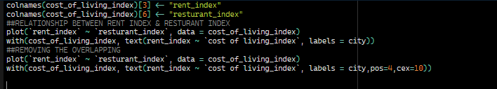

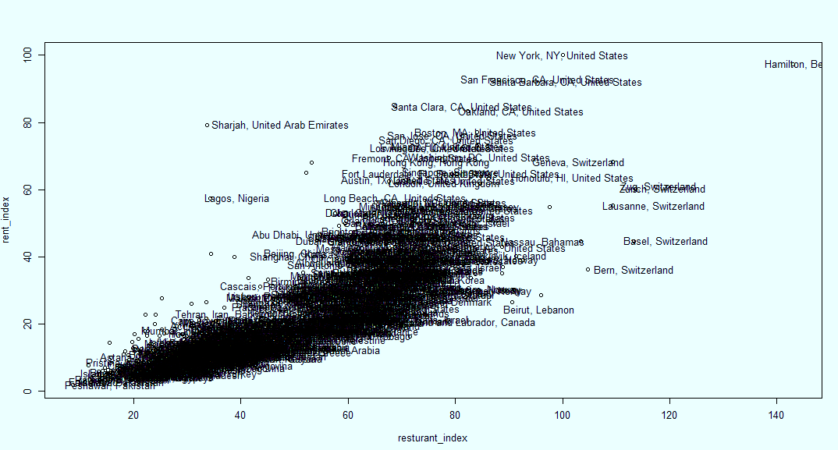

* following R codes were used to visualize clusters by using the fviz_cluster function.

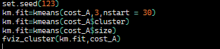

**2.6 RESULT ANALYSIS AND DISCUSSION**

This section will detail the outcomes of our clustering attempts. We've included a "cluster plot" or final plot to help you understand these data better.

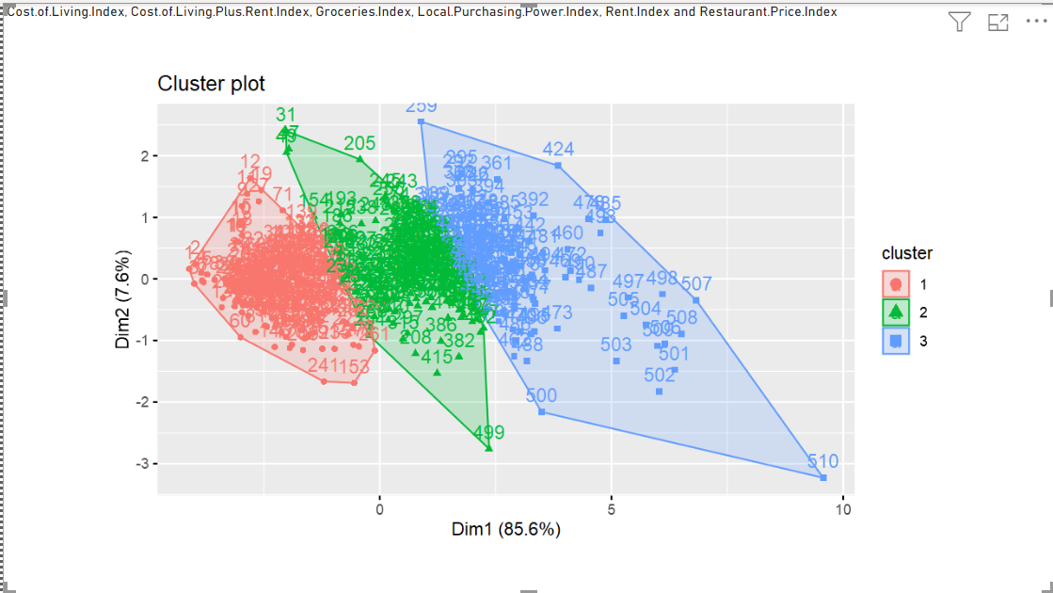

We achieved some data mining clustering results from this dataset. We were able to obtain some clustered data mining findings after applying our dataset to clustering data mining.

Firstly, we pre-process the data by removing any missing values and standardizing the cost-of-living index variable. We then use a clustering algorithm, such as k-means, to group the cities into clusters. After performing the cluster analysis, we can interpret the results by analyzing the characteristics of each cluster. For example, we may find that some clusters contain cities with a high cost of living index, while others contain cities with a lower cost of living index. Furthermore, we may identify patterns or trends within each cluster, such as a cluster of cities with a high cost of living index and a high cost of housing and transportation.

This information can be useful for policymakers and city planners who want to understand the factors that contribute to the cost of living in different cities and develop strategies for improving affordability. Overall, a cluster analysis of the cost-of-living index dataset can provide valuable insights into the relative affordability of different cities and the factors that contribute to the cost of living.

**2.7 CONCLUSIONS**

Cluster analysis is frequently used in many fields. Clustering is called unsupervised learning since it lacks a class label or a quantitative response variable, both of which are included in supervised learning methods such as classification and regression. Clustering is the division of data into related object groupings. Clustering is crucial in data mining applications such as scientific data exploration, information retrieval, text mining, and medical diagnostics.

**2.8 REFERENCES**

* Mirkin, B. (2011). Clustering for data mining: a data recovery approach. Chapman and Hall/CRC.
* Scikit-learn documentation on clustering algorithms: <https://scikit-learn.org/stable/modules/clustering.html>.

Task 03

**MARKET BASKET ANALYSIS USING ASSOCIATION RULE MINING**

**3.1 INTRODUCTION**

We are usually interested in the absolute number of consumer transactions (also known as baskets) that contain a specific set of objects (usually products) in association analysis. The examination of consumer purchasing behavior in supermarkets and chain stores, where they record the contents of shopping carts brought to the register for checkout, is a common use of association analysis. These transaction data are typically recorded by point-of-sale scanners and frequently consist of tuples of the following format: (transaction ID, item ID, item ID,...) A retailer can discover what is regularly purchased together and use this information to improve sales in a variety of ways by identifying frequent items. At its most basic level, association rule mining uses machine learning models to search databases for patterns or co-occurrences in data. It detects common if-then relationships, which are the association rules in and of themselves. An antecedent (if) and a consequent (then) make up an association rule.

An unsupervised non-linear approach called association rule mining in the R language is used to determine how the elements are related to one another. Frequent mining in it reveals which things are involved in a transaction or relationship together. Retailers, food stores, and an online marketplace with a sizable transactional database are the main users. Similar to how recommendation algorithms are used by any online social media, marketplace, and e-commerce websites to determine what you would purchase next.

**3.2 DATASET**

In this report we are going to discuss dataset, it is the various types of groceries we buy in our day today lives. Whipped/Sour Cream, Salt, Potato Products, Whole Milk, Frozen Vegetables, Fruit / Vegetable Juice, Sugar, Chocolate and Slide Cheese are some of goods that we are buy , by looking those data we can’t understand what goods consumer always buy . But we can gain our knowledge by studying how about consumer income, expenditure and their lifestyle.

The dataset contains 1000 rows of people's grocery store purchase orders. Using market basket analysis, algorithms like the apriori algorithm may analyze these orders and produce association rules. This dataset available in Kaggle that is maintain by UCI Machine Learning.

**3.3 EXPLANATION OF DATASET**

Market basket analysis set is the things we buy when we go to the market. As a consumer we buy typical things, at that time we buy usually goods and goods we buy infrequently. For an example we buy Bread, Milk, Eggs, Potatoes they are essential things, but we buy Ice Cream or Chocolate those things are not much want things.

Therefore, by analyzing these dataset we can point out what are the things we essentially want and things we don’t want for our day today lives. We can observe discounts and buy one get one free method and also promotion for daily purchasing products, by doing such things we can increase demand for essential goods in the market. We can do this easily when we understand consumer’s needs and wants.

Above mentioned dataset is the dataset we are going to analyze. This dataset represents transactions, and consumer’s preference was going to more, there are 999 objects with 17 variables in this dataset.

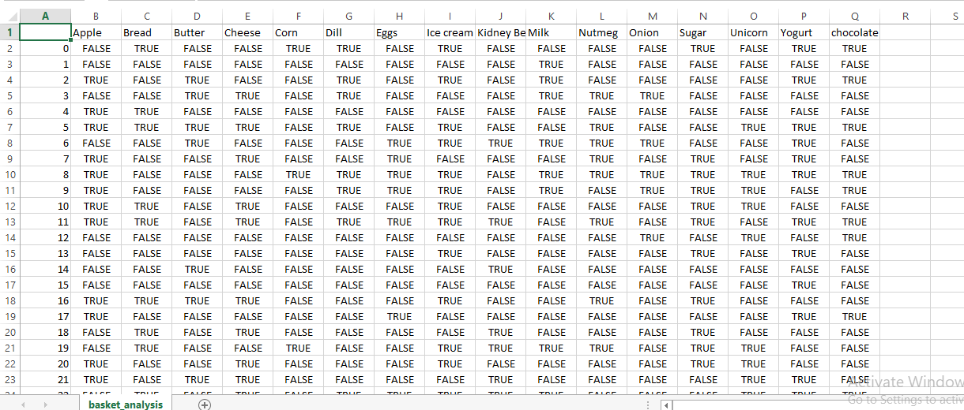

By looking these dataset, this looks variety of goods consumers buy for their day today lives.

**3.4 PREPARATION OF DATASET**

In this dataset we can see preference of the consumer’s completely various. To get the idea about this, we want to analyze this dataset and apply association rule mining using R software. We can analyze this data by using R software by using applications of association rule mining techniques. By analyzing dataset, we can get correct idea about consumer’s preference.

**3.5 IMPLEMENTATION IN R SOFTWARE**

R provides a helpful environment for statistical computing and design and offers a large range of statistics-related libraries. Additionally, because it’s practical for importing and cleaning data, many quantitative analysts utilize the R programming language as a programming tool.

When we analyzing data we have to application techniques to use, According to this data set by using “Names” function we can identify what are the items consumer bought within one time, this data set we can see those transactions, consumer like variety food some are not .

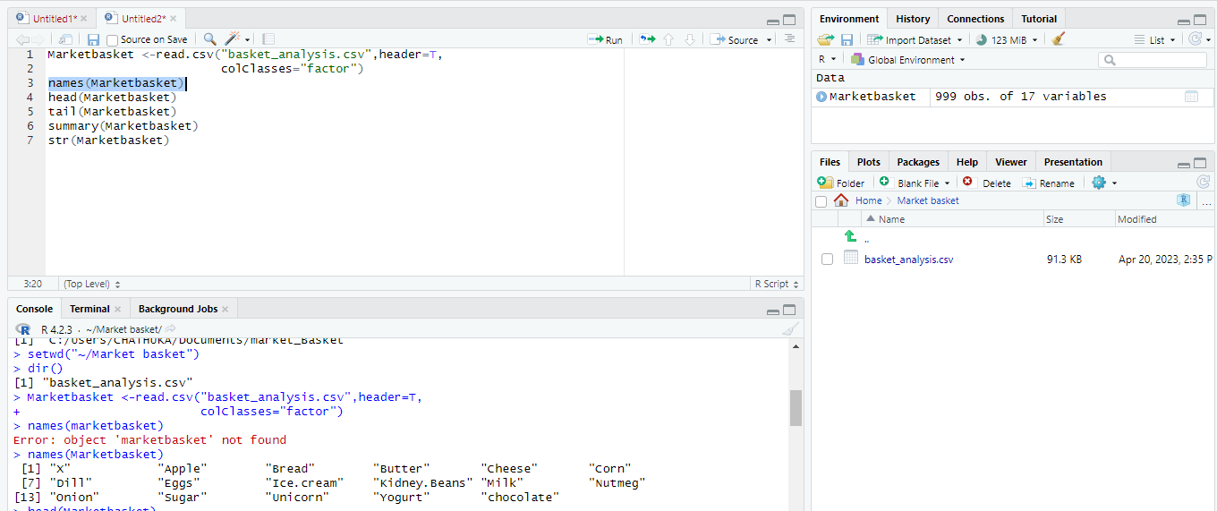

Next one is “head” function this return the first n rows for the object based on position. It is very useful for quickly testing objects has the right type data in it.

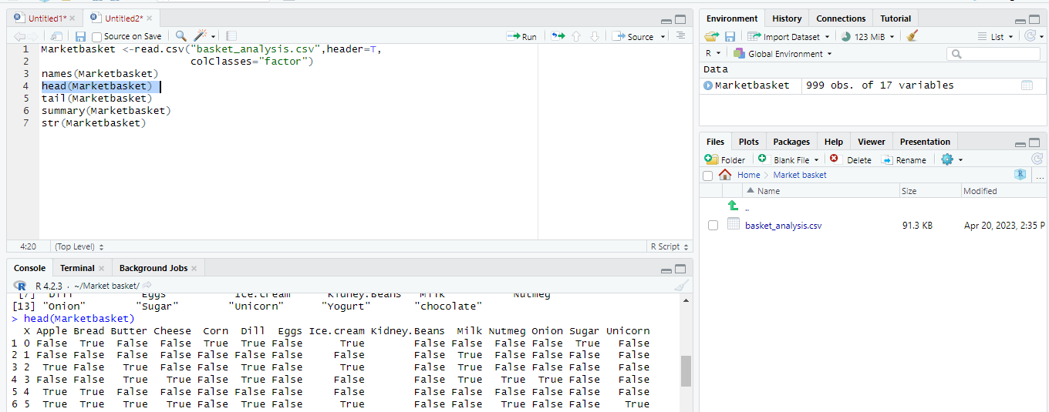

Other one is “tail” function it uses for get last rows of dataset. Normally we can point out vector or compatible object. In our dataset there are so many items by using head and tail functions we can point out all types of goods consumers much like to buy. We can grab all types of items by using both function like these dataset it is very important those two functions.

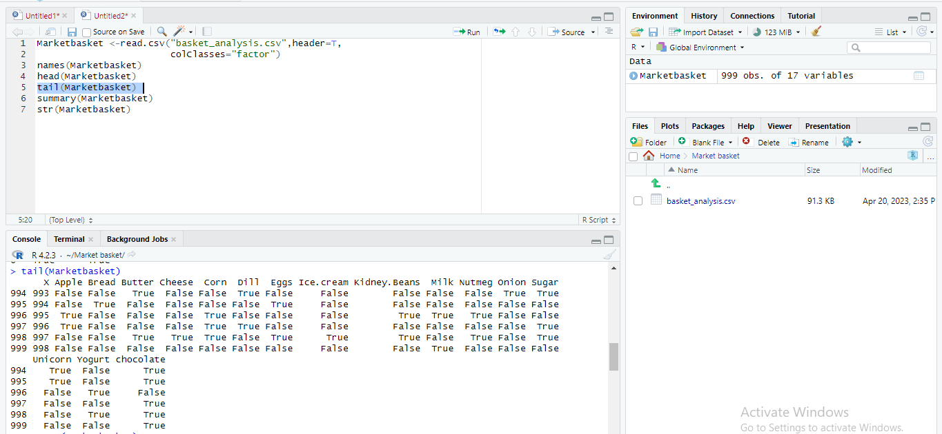

Also when doing analyzing “summery “function also a useful one. This provides statistical summary data for data set. The output of summery depends on the object we are looking at.

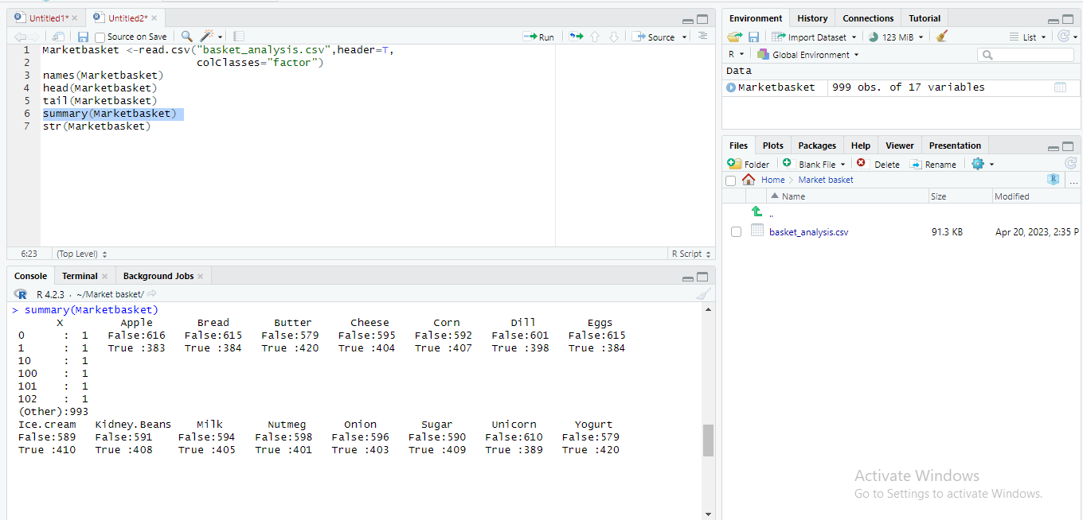

Last one is “str” function helps to examine the structure of data objects rather than providing a statistical summary.

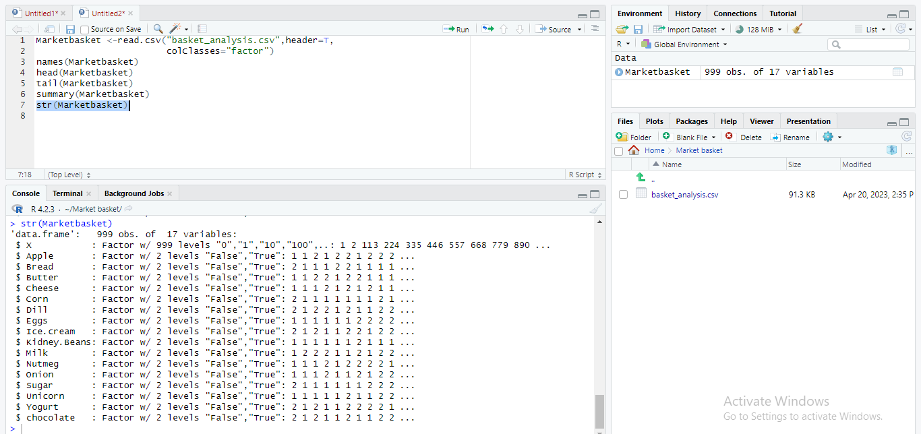

Dim function is also a useful function we can use to analyze dataset.

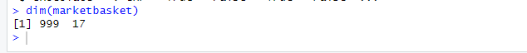

Now we want to create “bar plot” to get overall idea about dataset. To create it we want know sum of columns, because when we creating bar plot we want to labeled horizontal and vertical axis to get it we can use “colSums” function .

Let’s create a “Bar Plot” to get brief idea about dataset, when creating this we want previous “colSums” function results to create bar plot,

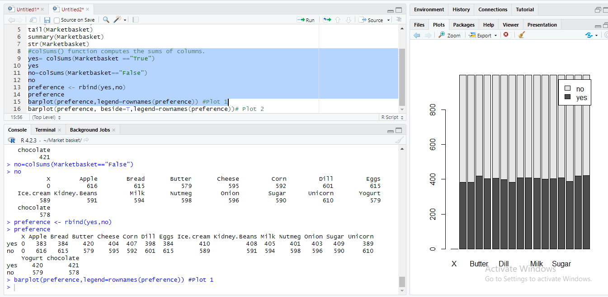

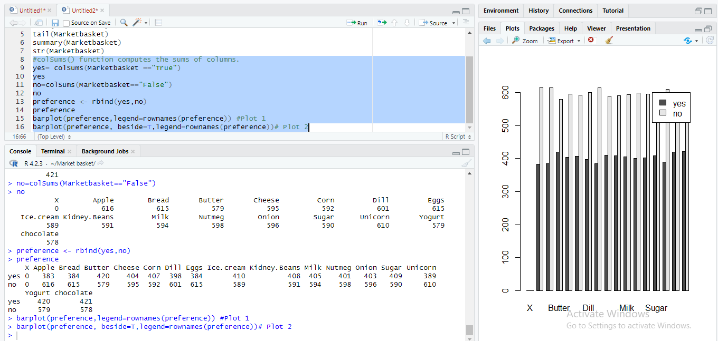

**3.6 DATA MINING**

Large data sets are sorted through in data mining in order to find patterns and relationships that may be used in data analysis to assist solve business challenges. Enterprises can forecast future trends and make more educated business decisions thanks to data mining techniques and technologies. Data mining is a crucial component of data analytics as a whole and one of the fundamental fields in data science, which makes use of cutting-edge analytics methods to unearth valuable information in data sets. Successful analytics projects in organizations depend on data mining.

To make final results we want to install some packages named “arules” we want to install this package and activate it, to get correct final decision. Arules package is powerful tool for mining associative transactional databases. Arules package is use for Apriori Algorithms , this apriori algorithm use for frequent item set mining and association rule learning over relational data base.

We can install package by,

Install. Packages (“arules”) # install “arules” package.

Library (arules) # activate “arules” package

If we already exists that software will show it but by enter this code if it shows error we want to install it,

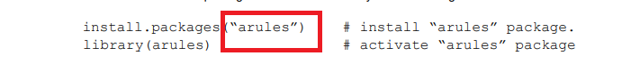

To do it we want to put, **‘’** above mentioned word “arules” after do it and run the code we can automatically install Arules packages to our software.

The apriori () function from the arule package implements the Apriori algorithm to create frequent item sets. Note that, by default, the apriori () function executes all the iterations at once.

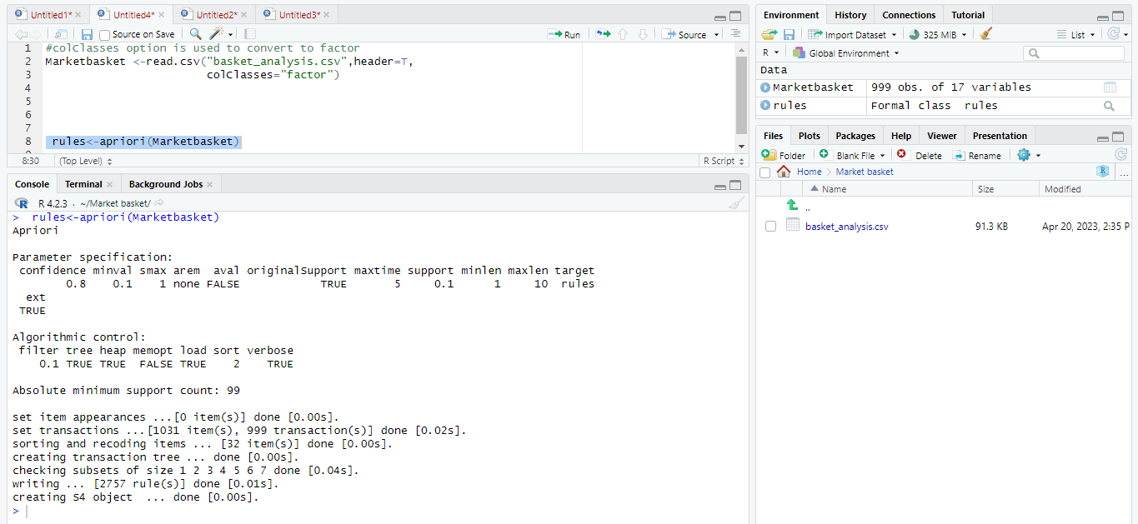

We can get summery of the dataset by using “summery” function by using apriori algorithm based aruel package,

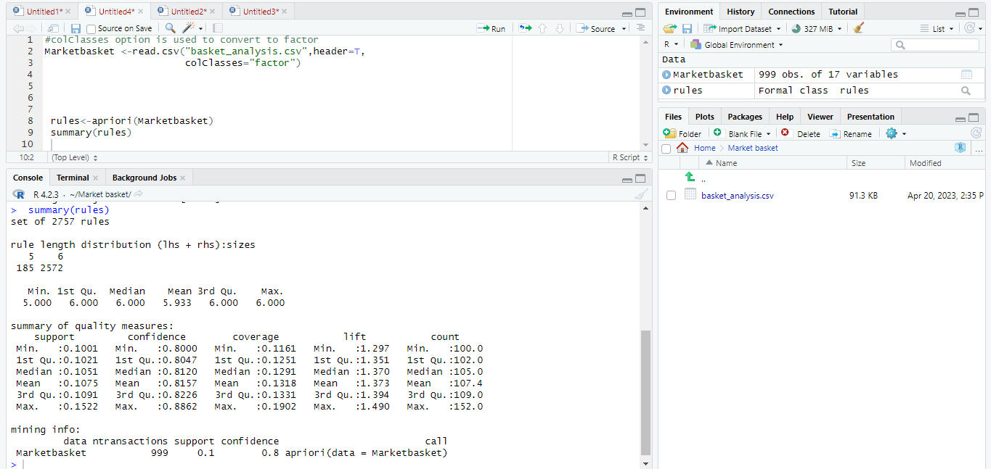

We are interest what is the most popular food item in market basket. We can do it easily by using this package,

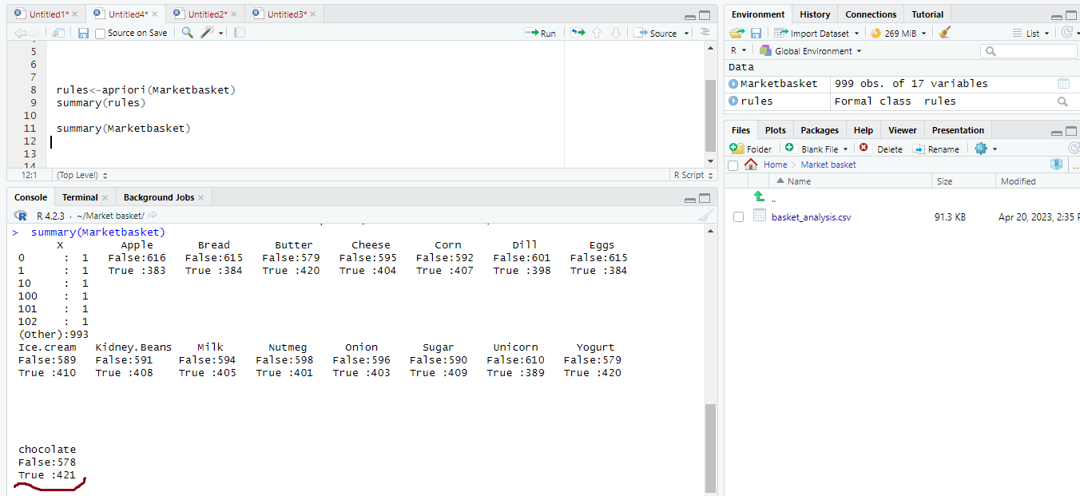

By looking this calculation we can see most popular food item is goes to chocolate. By looking following graph we can clearly get it,

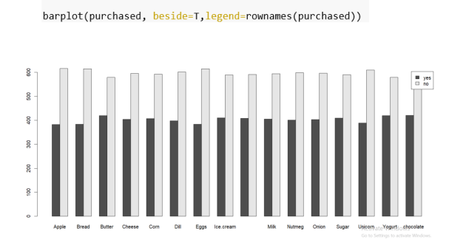

Now we are going to which customer bought more items, before do this we want to install package “arulesViz”, by installing and activating this we can analyze which customer bought many items. This package provides various visualization techniques for association rules and items. This package include several interactive visualization for rule exploration.

According to the plot chocolate are the most popular items. Since we want to see rules where customers are buying more of the items, so use the following code to get those rules for chocolate,

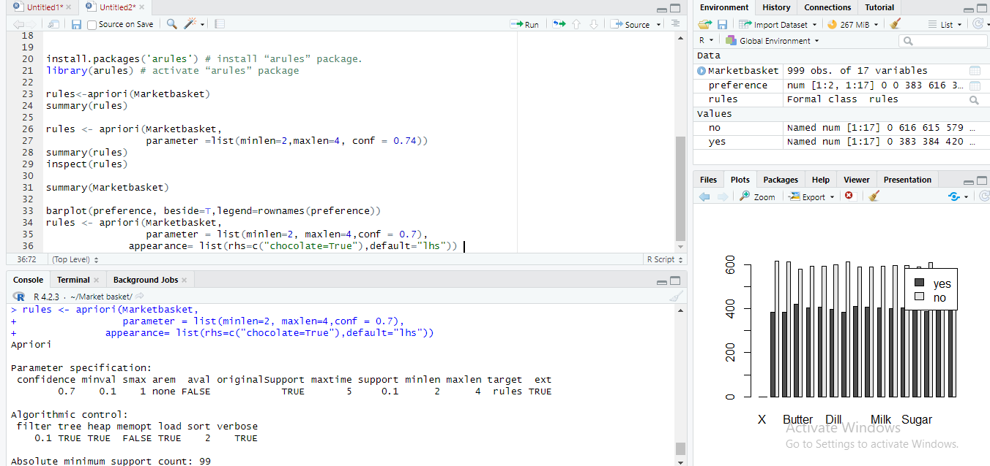

When we doing analyzing and visualization thing following paths we use to do it, following things are some of them.

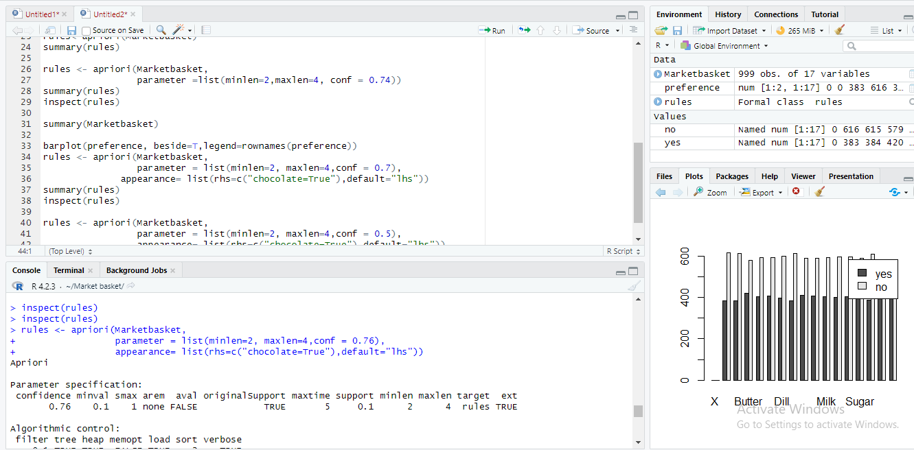

Following graph represent which customer purchased more items,

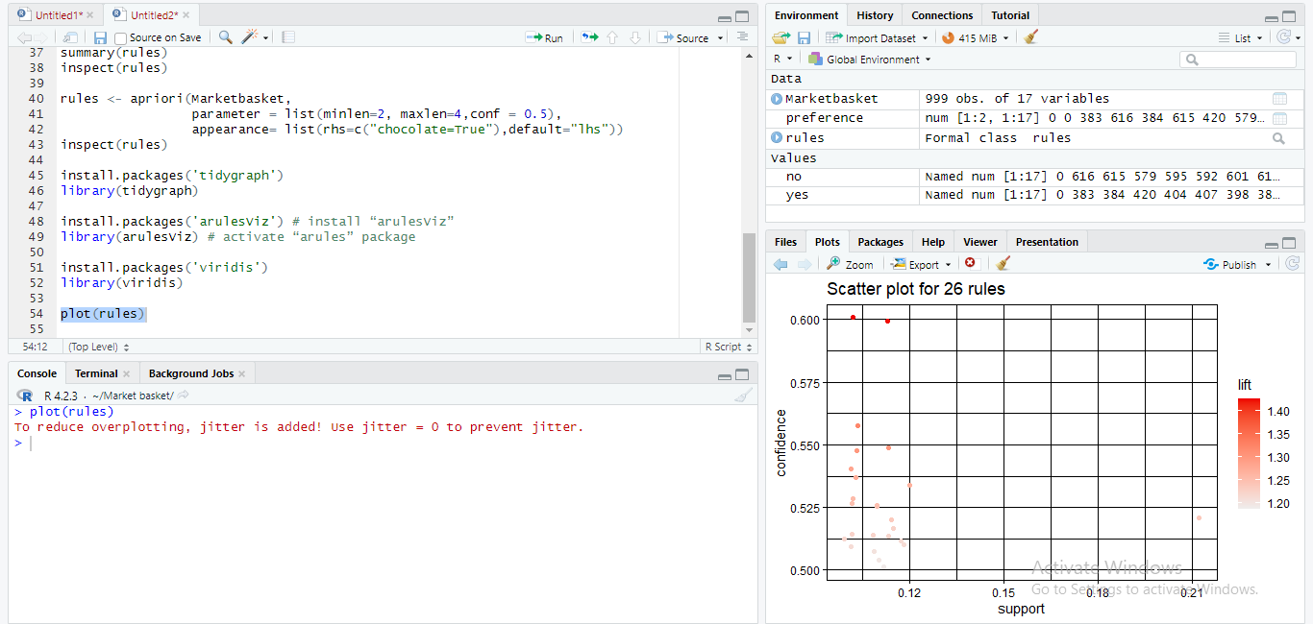

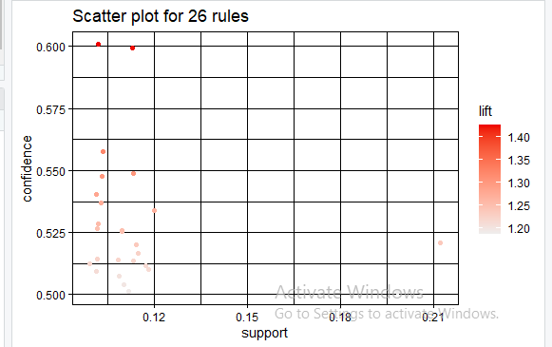

Furthermore, we can analyze this data set by using other plots also,

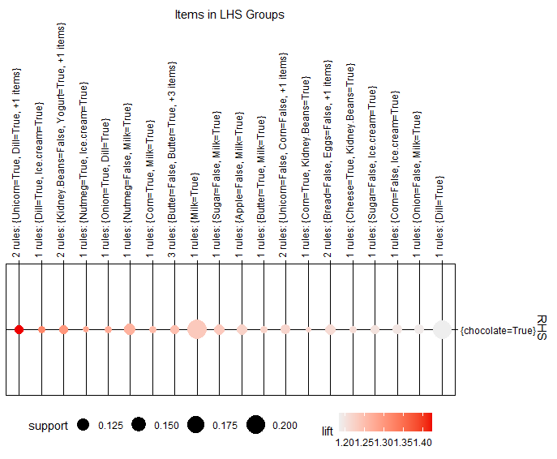

Then we used the rule Explorer function to explore association rules using interactive manipulations and viewing using shiny,

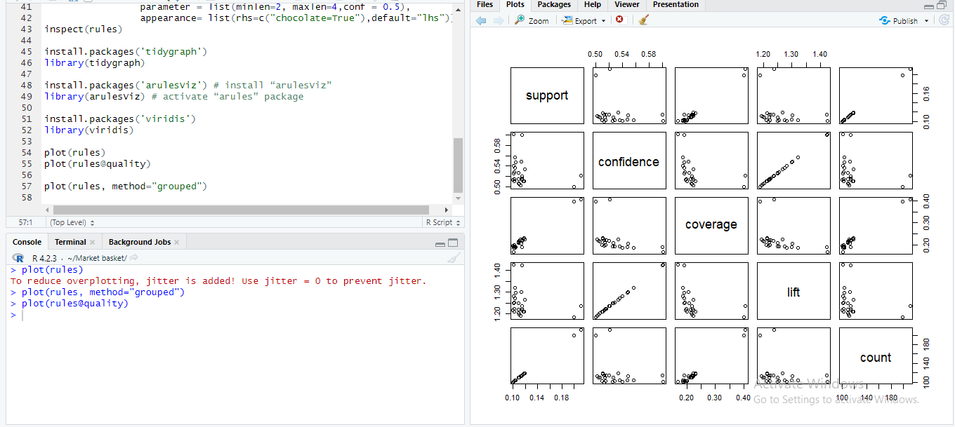

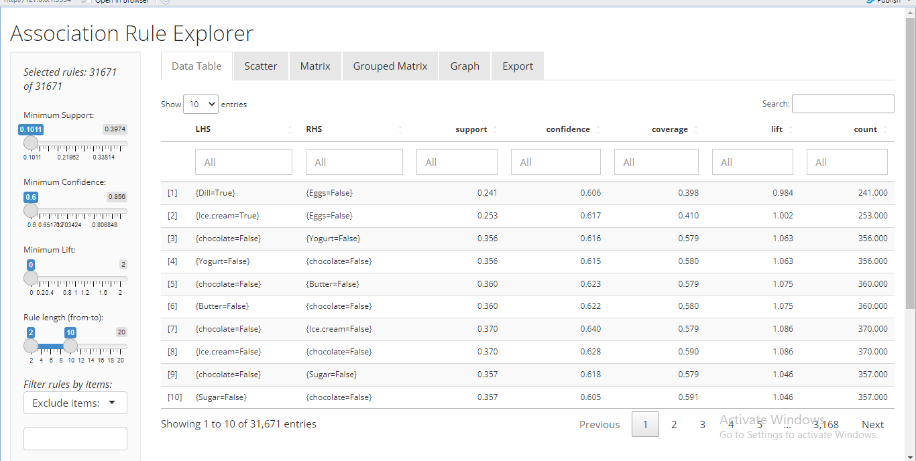

Items which have false values are selected from the right-hand side and left-hand side to exclude because in most cases any rules which contain purchased items “No” cannot be seen.

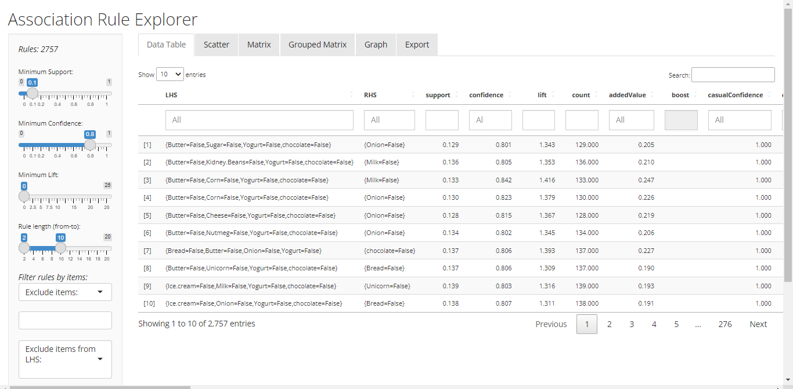

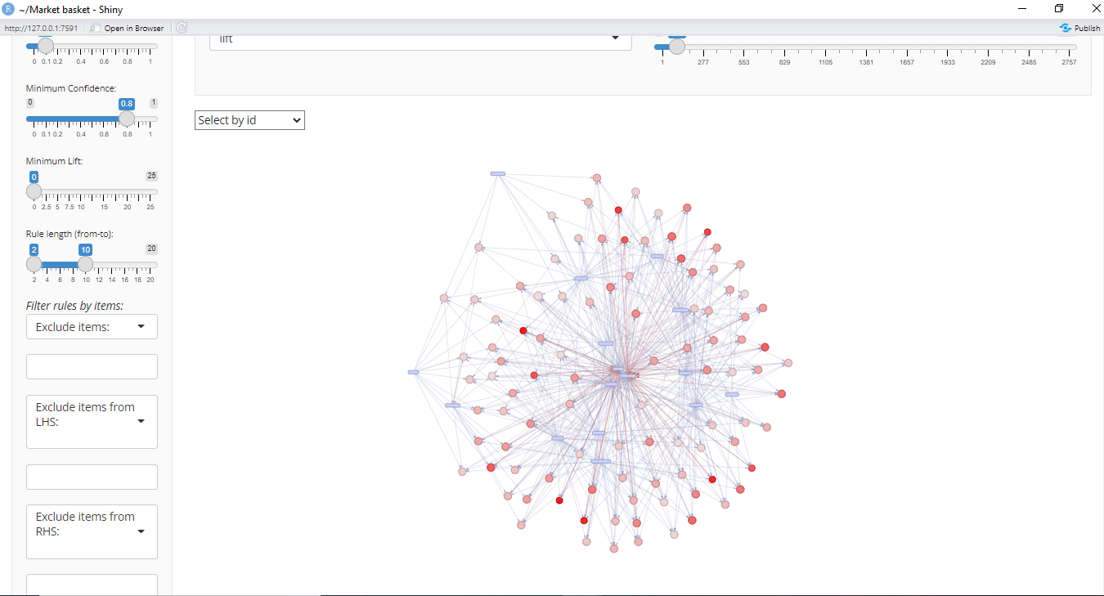

Now we have brief idea about this database using R programming and other data mining concept, with the help of these method we analyzed volatility of consumer.

**3.7 RESULTS ANALYSIS AND DISCUSSION**

Now as a final step we going to discuss about our results analysis. By using association rule mining, data mining steps and do visualization using R programming. Now we are going to discuss what we got from analyzing data sets.

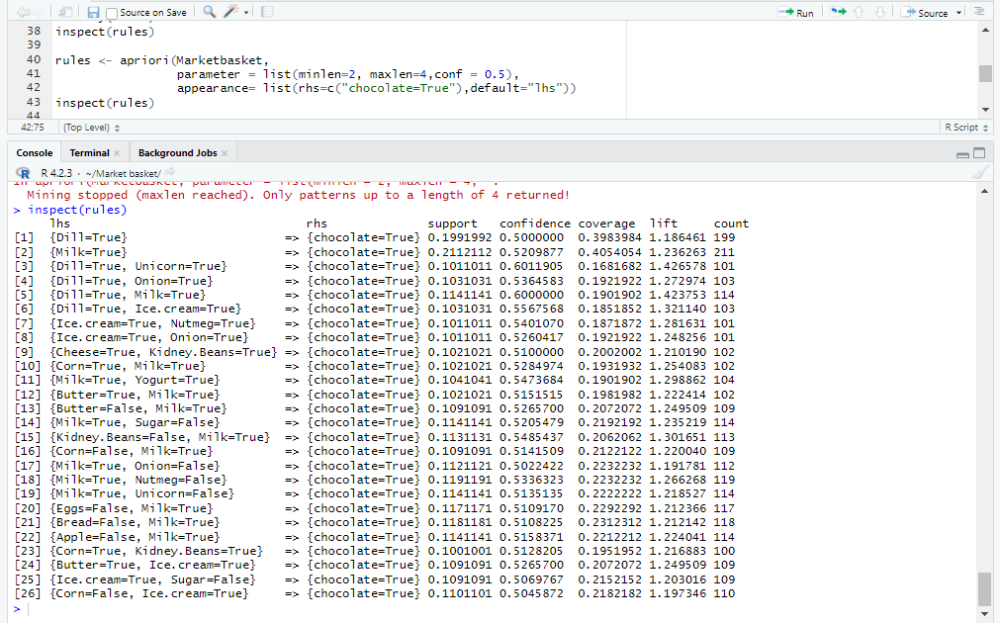According to this analysis we can say if a customer buys Dill with a confidence of 40 % will buy chocolate with a confidence of 40%. And if customer buy Eggs, they buy chocolate with the confidence of 42%. This analysis was done according to the most popular food item “chocolate”.

By using implementation of R programming and using data mining techniques and by doing visualization of dataset we got these results.

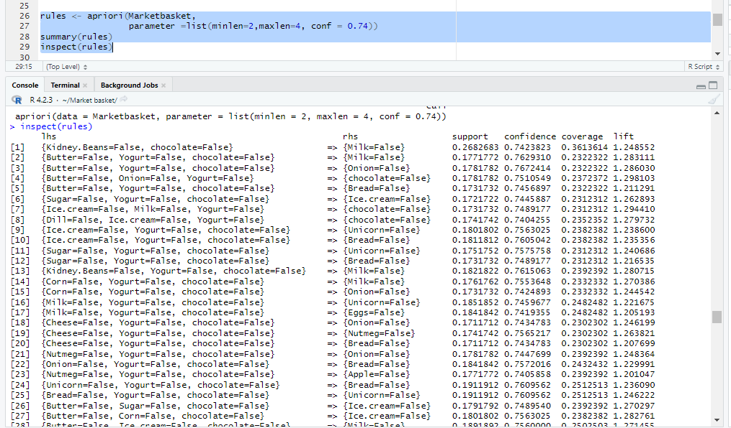

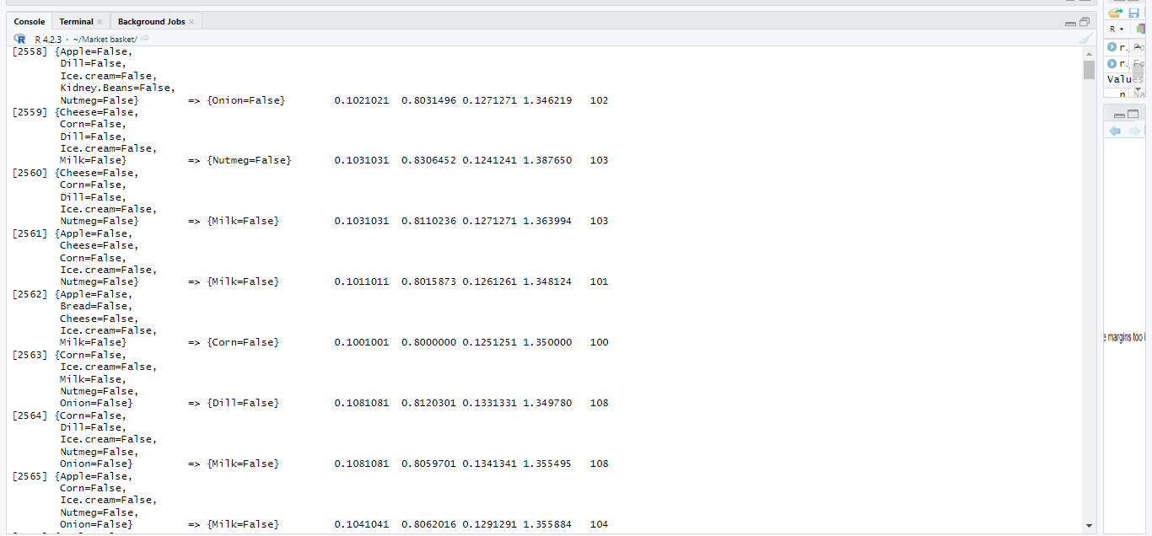

Above this picture if customer buy apple and sugar together script say 54.94% confidently, he will buy butter in row 1006. And also, if the customer buys milk and chocolate together script say 54.02% confidently, they he will buy dill in row 2613.

Data mining in implementing R, different rules were to find and check how items are purchased by customers. Chocolate is the most popular item in the basket, according to the data set. Finally, by using the rule explorer function all the false values were executed because when we purchase an item false or not cannot be used. Thus, the graph is the result of all the true values. So, if we apply this method to understand the sales of the store and use this method to find the relationship between the goods, we think it would be helpful for increasing huge part of efficiency in a store.by studying these results we can get knowledge about consumer’s preference by using that we can increase demand for goods understanding customer preference is best way to increase sales of the market , the better way to find out these is association rules mining method using R programming is very suitable.

**3.8 CONCLUSION**

Association rules are helpful in data mining for studying and forecasting consumer behavior. Customer analytics, market basket analysis, product clustering, catalog design, and retail layout all benefit from their use. Association rules are used by programmers to create machine learning-capable software. Association rules are employed in data science to discover correlations and co-occurrences between data sets. Best used to explain patterns in data from databases like relational databases and transactional databases that appear to be separate sources of information. Sometimes the process of applying association rules is referred to as "association rule mining" or "mining associations."

If customer buy bread, they definitely buy butter like that if customer buy pizza they definitely buy cola or some kind of juice, like that customer buy various kind of matching foods so we can give promotions, “buy one get one or more free “method to increase our sales in the market, it is very important to understand customer’s preference with the help of that we can increase market demand. By using data mining methods like association rule mining we can correctly do it easily.

**3.9 REFERENCES FOR TASK 03**

To get idea about data mining: <https://www.techtarget.com/searchbusinessanalytics/definition/data-mining>

What is association rule mining & importance of association rule mining:

<https://www.geeksforgeeks.org/association-rule/>

<https://www.javatpoint.com/association-rule-learning>

Dataset:

<https://www.kaggle.com/datasets/ahmtcnbs/datasets-for-appiori?select=basket_analysis.csv>

**TASK 04**

**POWER BI DASHBOARD FOR COST OF LIVING.**

**4.1 Introduction**

Cost of living is one of the main concerns nowadays due to inflation. This Power BI dashboard provides a comprehensive view of the key factors that contribute to the cost of living, including rent, groceries prices, restaurant price of each country and city. This dashboard helps to understand where the cost is higher and where the cost is lower. So, this information can be used to get important decisions, such as where to live or where to do business. This dashboard represents the variation of cost-of-living indexes by using interactive graphs, tables, and map. The clustering plots of this dashboard is obtained from R codes.

**4.2 Exploration of dataset**

The dataset that we used to create this dashboard is cost_of_living_index dataset which we used for clustering (task 3). This dataset had 511 rows and 7 columns, then we additionally inserted another column named “Country” which is obtained from the “City” column in the dataset by using Microsoft Excel. The dataset didn’t have any NULL values.

**4.3 Dashboard Design & Implementation**

Our Power BI Dashboard contains 6 pages as follows.

**Cover Page**

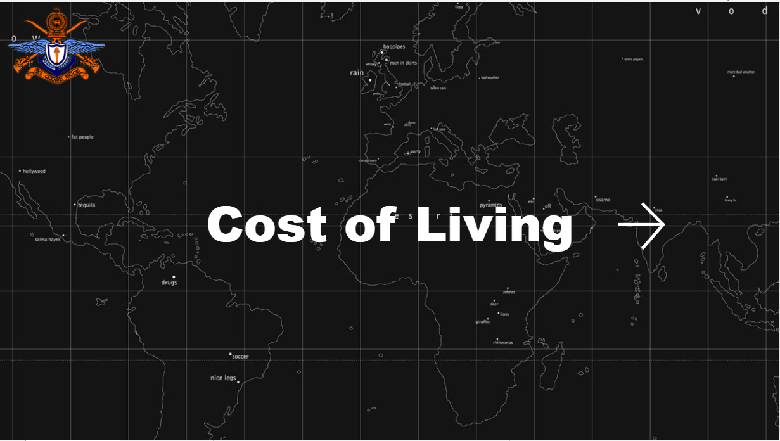

**Dashboard**

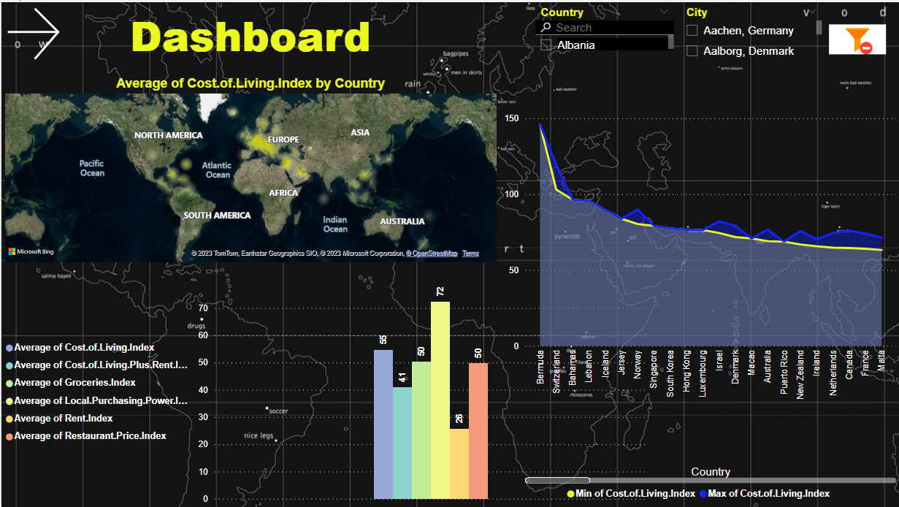

**Clustering 1**

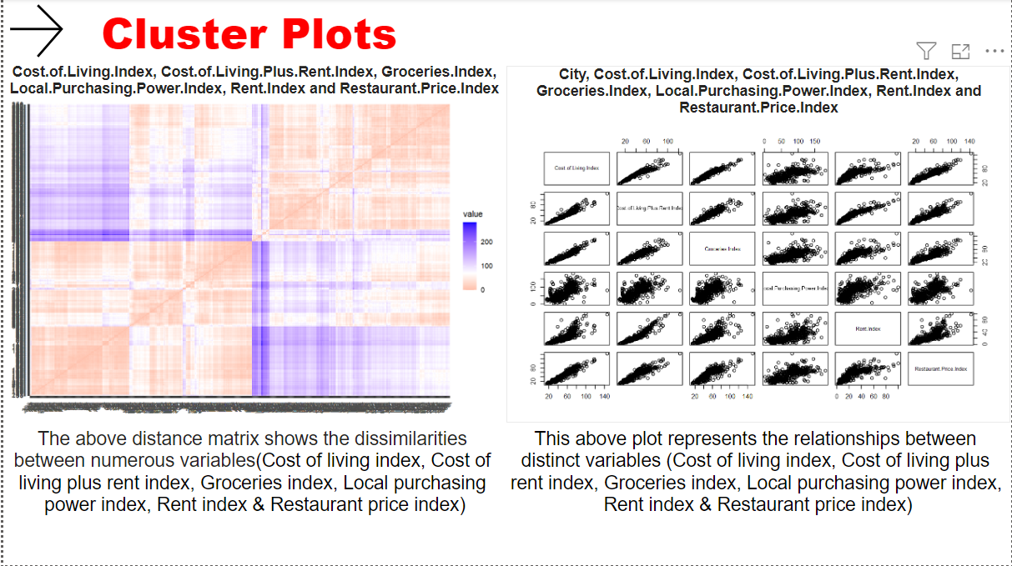

**Clustering 2**

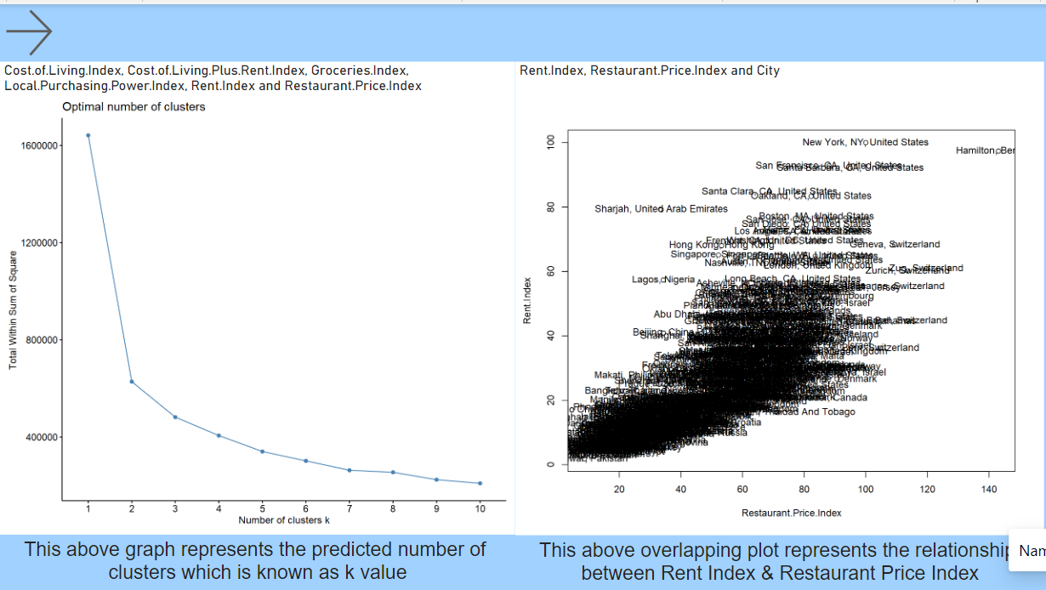

**Clustering 3**

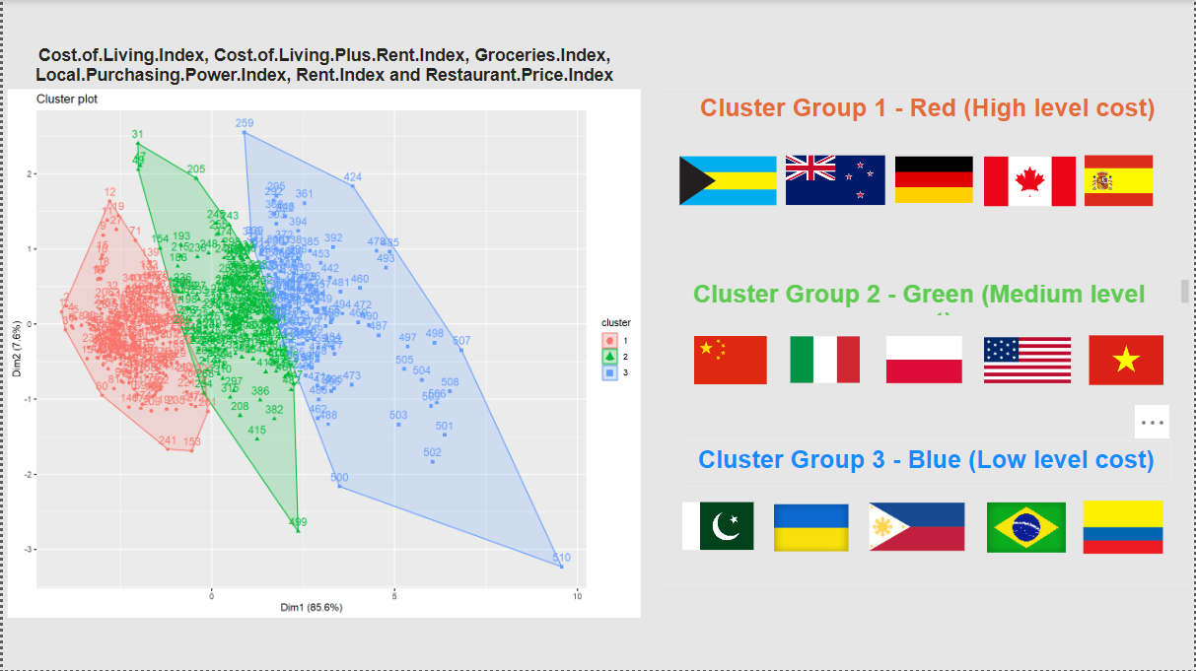

**Thank You page**

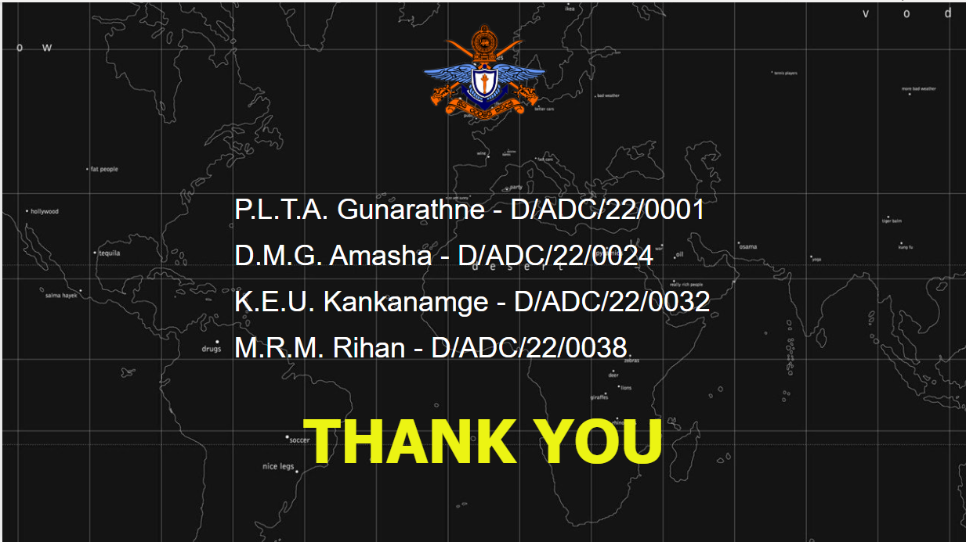

The following are the main steps that we followed to create the dashboard.

* Importing the dataset to Power BI by using R script

Start Power BI, Get Data, More, R Script (Imported the dataset using following code)

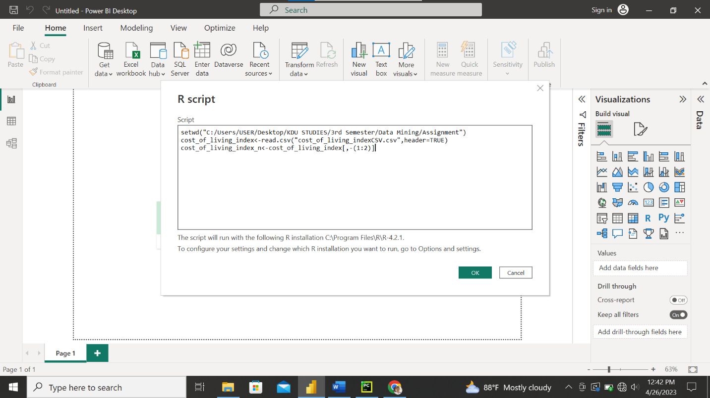

**Cluster Plots**

* **Data Pairs Visualization**

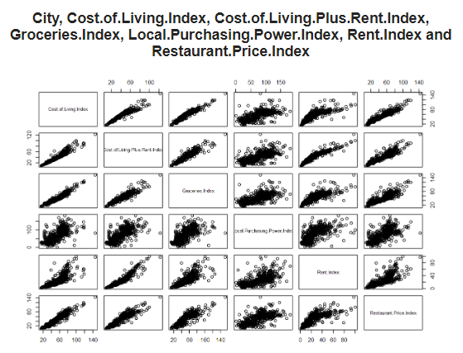

The above plot is a matrix of scatterplots, where each variable is plotted against every other variable in the data which represents the relationship among each variable (Cost of Living Index, Cost of Living Plus Rent Index, Groceries Index, Local Purchasing Power Index, Rent Index, Restaurant Price Index). The following R code was used in the R script of Power BI to create the above visual.

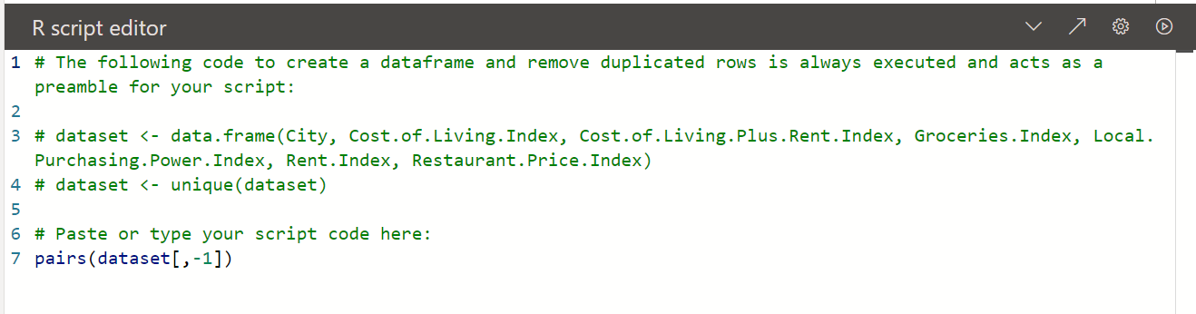

* **Dissimilarities between Indexes**

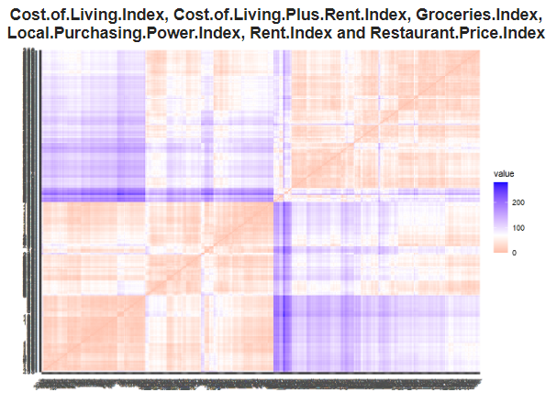

The above plot displays the distance between rows of the dataset. **Factoextra R Package** is used to create the above plot. Distance matrix is used to visualize dissimilarities of indexes. According to the chart red color shows high similarity (low dissimilarity) and blue color shows low similarity. The following R code was used in the R script of Power BI to create the above plot.

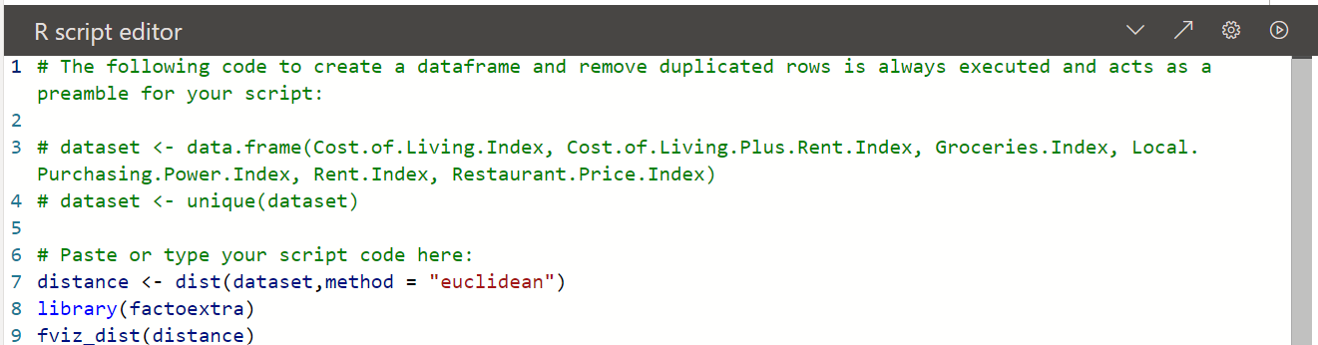

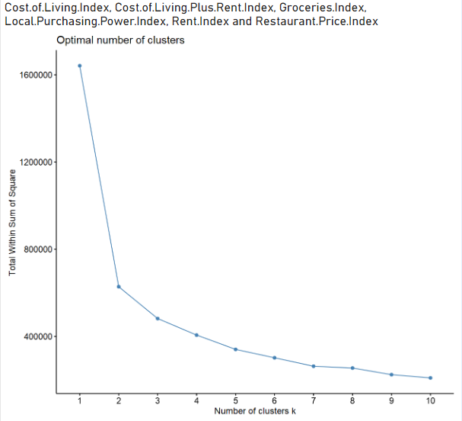

The above graph represents the predicted number of clusters which is known as k value. The following R code was used in the R script of Power BI to create the above plot.

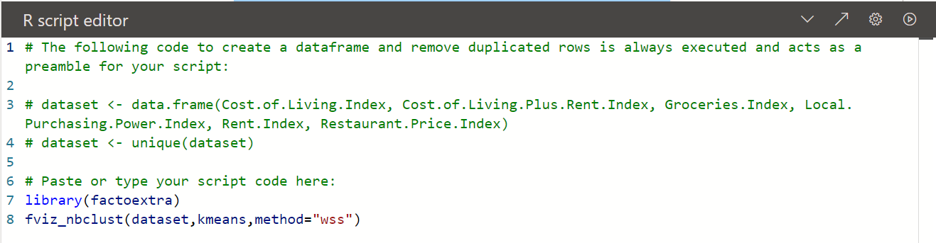

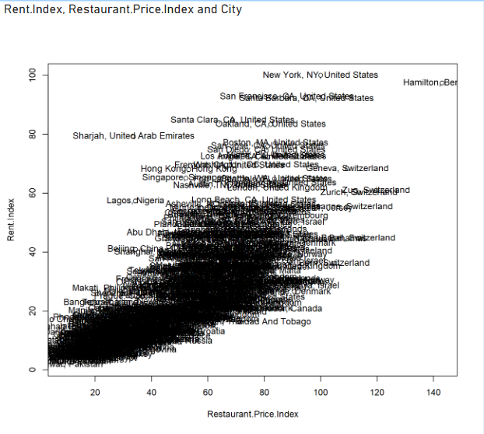

The above overlapping plot represents the relationship between Rent Index and Restaurant Price Index. The following R code was used in the R script of Power BI to create the above plot.

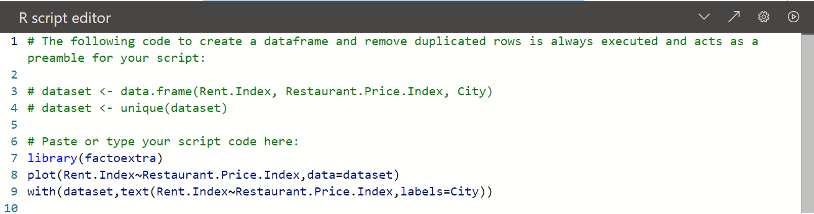

* **Cluster Plot**

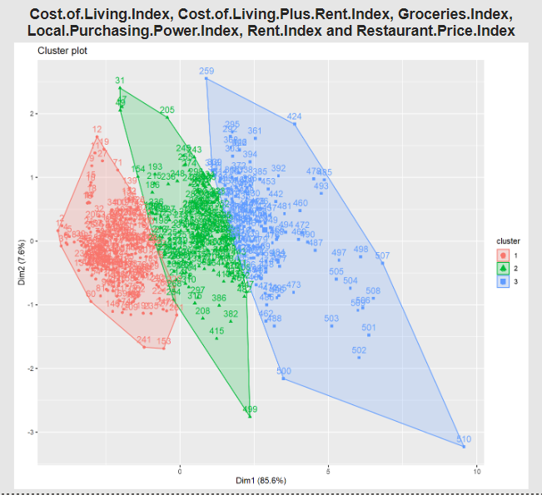

The above plot represents 3 cluster groups as high-level cost (red), medium level cost (green) and low-level cost (blue) cities and countries. From the above cluster groups, we can identify countries like New Zealand, Canada, Germany, Spain, and Bahamas are belong to high level cost countries. Countries like China, Italy, Poland, Vietnam are belonged to medium level cost. Countries like Pakistan, Brazil, Philippines, Colombia, Ukraine are belonged to low level cost. The following R code was used in the R script of Power BI to create the above cluster plot.

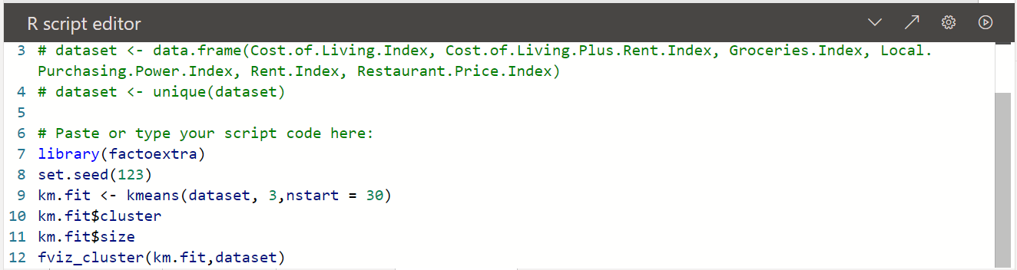

**Dashboard**

* **Slicers**

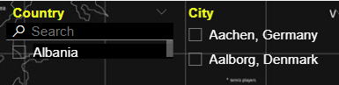

We used above two slicers to filter the details by country and city.



The above button is used to clear all filters applied in the dashboard. For that we have to press CTRL + BUTTON

* **Map**

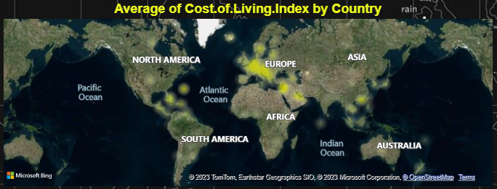

The above map shows the Average of Cost of Living Index by Country. Yellow color shows the magnitude of index. For this map we used the City, Country and Cost of Living column in the dataset.

* **Area Chart**

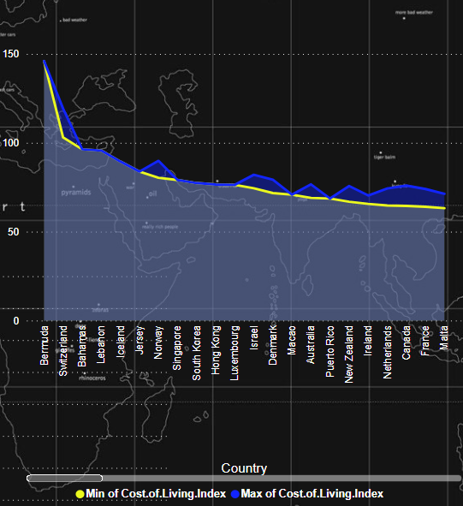

The area chart shows the values and variations of minimum of Cost of Living Index (Yellow) and Maximum of Cost of Living Index (Blue) by Country

* **Clustered Column Chart**

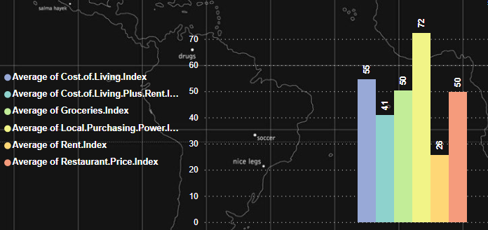

The Clustered Column Chart shows the values and variations of Averages of each variable (Cost of Living Index, Cost of Living Plus Rent Index, Groceries Index, Local Purchasing Power Index, Rent Index, Restaurant Price Index)

**4.4 Conclusion**

A dashboard summarizes the main data of a dataset in the form of graphs and plots. A dashboard helps us to understand the data more easily and it helps us to make proper decisions. Therefore, from our dashboard, a person can get a good idea about the living costs in each country, can compare the living costs among each country & cities and can identify the countries with high level cost, low level cost and medium level cost. This information will be useful for the people who like to migrate to another country or to the people who like to start a business or a company in another country. Finally, this report summarizes the methods that we have used to create the dashboard.